



Project Name: CONNECTING TO DOCTOR

Branch PG-DAC March- 2022.

Documentation On

**“CONNECTING TO DOCTOR”**

PG-DAC Sep 2021

**Guided By:**

*Mr.Dhan sigh sir*

Submitted By :

**Group No: 10**

* **Jawale Harshal 220343420030**
* **Mungase Shubham 220343420093**
* **Butkar Atish 220343420024**
* **Ukey Neha 220343420051**
* **Jaiswal Akash 220343420007**

# CERTIFICATE

This is to certify that the project entitled

**“CONNECTING TO DOCTOR”**

Has been satisfactorily completed by:

* **Jawale Harshal 220343420030**
* **Mungase Shubham 220343420093**
* **Butkar Atish 220343420024**
* **Ukey Neha 220343420051**
* **Jaiswal Akash 220343420007**

Under supervision and guidance for partial fulfillment of the

**PG Diploma in Advanced Computing (DAC) Course**

Of

Center for Development of Advanced Computing (C-DAC), Pune. At

**Academy of Information Technology(YCP) Nariman Point, Mumbai-400 021.**

**Pradnya Kanoja**

**Course Co-ordinator**

**Batch:** DAC March 2022 Batch

**Date:**

## ACKNOWLEDGEMENT

We have taken efforts in this project. However, it would not have been possible without the kind

Support and help of many individuals. We would like to extend our sincere thanks to all of them. We are highly indebted to our guide **Mr.Dhan singh sir** for his guidance and constant supervision as well as for providing necessary information regarding the project and also for his support in Completing the project.

We express our thanks to our Director **Mr.S.N.Guptan** and our Course coordinator **Miss. Pradnya Kanoja** for extending their support. We would also thank our Institution and the facultymembers without whom this project would have been a distant reality. Our thanks and appreciations also go to all people who have willingly helped us out with their abilities.

**SUBMITTED BY**

* **Mr. Jawale Harshal**
* **Mr. Mungase Shubham**
* **Mr. Butkar Atish**
* **Mrs. Ukey Neha**
* **Mr. Jaiswal Akash**

**(March 2022 Batch)**

## ABSTRACT

The purpose of our Project “Connecting-To-Doctor” is to automate the process of getting medical treatment and health check-up in a way that saves both time and effort. It manages all the information of patient and doctors. The project is developed at administrative end and thus only the administrator is guaranteed to have access to everything. The purpose of this project is to create a web application that reduces the manual efforts of looking for a doctor and booking appointments. This web based system developed using React, Spring Boot, and MySQL server for database.

The purpose of our Project “Connecting-To-Doctor” is to automate the process of getting medical treatment and health checkup in a way that saves both time and effort. This web based system

**Table of Contents**

**1. Introduction 7**

1.1 Document Purpose **7**

1.2 Project Background **7**

1.3 Aim & Objectives **7**

**2. Business Requirements Overview**…………………………………………………………**8**

**3.Functional Requirements** **8**

3.1 Admin Module **8**

3.2 Doctor Module **9**

3.3 Patient Module **9**

**4.** **Non-Functional Requirement………………………………………………………………9**

**5. Use Case Diagram 10**

5.1 Admin **10**

5.2 Doctor **11**

5.3 Patient **12**

**6. Database Design 13**

.

**7. E-R Diagram………………………………………………………………………………16**

**8. Snapshots ……………………………………………….…………………………………17**

**9. Conclusion , Future Scope , References .………………………………………………...34**

**List of Figures**

**Use Case Diagrams 7**

Fig 1 Admin 7

Fig 2 Doctor 8

Fig 3 Patient 9

Fig 4 ER Diagram 12

1. **Introduction:**
   1. **Document Purpose:**

This document explains the system requirements and scope for developing Connecting To Doctor portal. Connecting To Doctor portal could divide the three main parts, Admin part, Patient part and Doctor part.

## Project Background:

During pandemic Covid-19 was on high priority and almost all doctors were on duty at Covid-19care centers which lead to negligence towards other diseases. Many patients suffered amidst pandemic due to unavailability of doctor’s appointment. Lockdown restrictions made it more difficult to get information about available appointment slot and doctor’s availability. Conventional medical treatment and health checkup is proven to be not feasible in these pandemic like situations. There has to be some virtual medium which will provide ease to both patients and doctors.

## Aim & Objectives:

* The purpose of our Project “Connecting To Doctor” is to automate the process of getting medical treatment and health checkup in a way that saves both time and effort.
* This application manages all the information of patients and doctors.
* The project is developed at administrative end and thus only the administrator is guaranteed to have access to everything.
* This web application reduces the manual efforts of looking for a doctor and booking appointments.

1. **Business Requirements Overview:**

* Connecting To Doctor is the public web application.
* Connecting To Doctor will be opened to the global, but in the phase 1, the main target is in the Maharashtra.
* There are mainly two types of users. One is the Doctor and other is Patient.
* Patients can search for the available specialist Doctors in respective location.
* Doctor can create appointment slots based on available time and can check information about the booked appointments.
* Connecting To Doctor provides the facility to connect the patients with the doctor efficiently.
* Connecting To Doctor could be maintained by Administrator.

# Functional Requirements Overview:

Connecting To Doctor consists of three modules described as below.

1. Admin Module
2. Doctor Module
3. Patient Module

# **Admin Module**

* Connecting To Doctor provide all functionality to admin how to handle the System.
* Admin can register the new doctor when credentials found authentic.
* Admin has controls and can see the Patient details and Doctor details.
* Admin can see the Patient details and also if admin found any details in-appropriate, admin can delete those entries.
* Admin can see the Doctor details and also if admin found any details in-appropriate, admin can delete those entries.
* Admin can deactivate the Patient or Doctor temporarily or permanently.
* Admin can add Area, City, State according to the need.

# **Doctor Module**

* Doctor can update his profile as per his/her requirements.
* Doctor can see the current appointments and appointment history.
* Doctor can cancel appointment in case of emergency.
* Doctor can update timetable according to availability and holidays.
* Doctor can change existing password.

# **3.3 Patient Module**

* Patient can update his profile as per his/her requirements.
* Patient can search doctors according to locality and specialty of doctor.
* Patient can see the current appointments and appointment history.
* Patient can cancel appointment in case of emergency.
* Patient can change existing password.

1. **Non-Functional Requirement:**

* The website should use professional design, look and feel and color scheme.
* Users will have no limitations for accessing the application through Internet. The portal being an internet application, it is difficult to specify exact number of visitor or users. Hence, we will target the system to support between 5 and 10 million users on launch of phase 1.
* Being a public website, the site must follow general usability guidelines for menus, navigation, colors, links and other actions provided on the screens.
* The system should be designed in such a manner that user will be able to complete tasks in minimum number of steps.

## 5. Use-Case Diagram

**5.1 Admin**

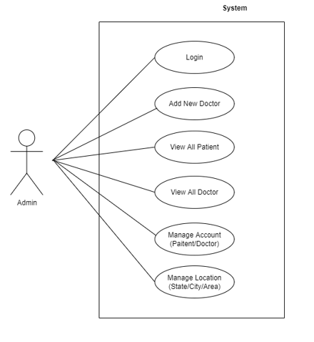

`Fig. Use-Case Diagram for Admin

## 5.2 Doctor

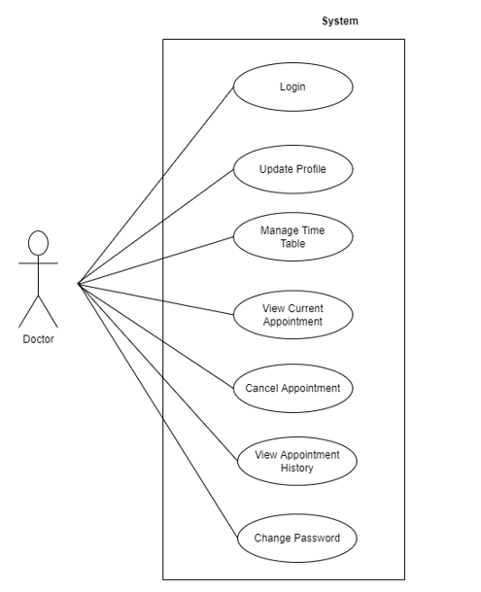

Fig. Use-Case Diagram for Doctor

**5.3 Patient**

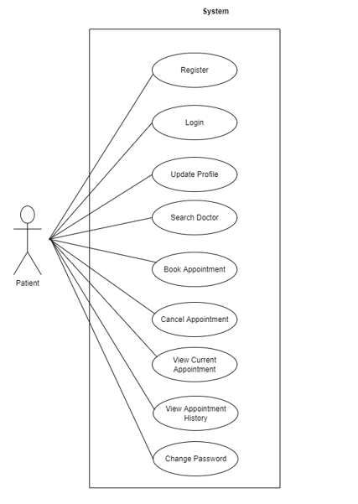

Fig. Use-Case Diagram for Patient

**6. Database Design:**

**1] Login table**

|  |  |  |  |  |  |
| --- | --- | --- | --- | --- | --- |
| **Field** | **Type** | **Null** | **Key** | **Default** | **Description** |
| login_id | Integer | No | Primary key | AI | Login ID |
| user_name | Varchar(45) | No |  |  | User Name |
| password | Varchar(45) | No |  |  | User Password |
| user_type | Varchar(10) | No |  |  | Patient/ Doctor/ Admin |
| status | Varchar(10) |  |  | active |  |

**2] Doctor table**

|  |  |  |  |  |  |
| --- | --- | --- | --- | --- | --- |
| **Field** | **Type** | **Null** | **Key** | **Default** | **Description** |
| doctor_id | Integer | No | Primary key | AI | Doctor ID |
| first_name | Varchar(45) | No |  |  | First Name |
| last_name | Varchar(45) | No |  |  | Last Name |
| mobile_number | Varchar(45) | No | Unique key |  | Mobile Number |
| gender | Integer | No |  |  | Gender |
| dob | date | No |  |  | Date Of Birth |
| graduation | Varchar(45) | No |  |  | Graduation |
| post_ graduation | Varchar(45) |  |  |  | Post Graduation |
| speciality | Varchar(45) | No |  |  | Speciality |
| fees | Integer | No |  |  | Fees |
| area_id | Integer | No | Foreign key |  | Reference to area id |
| login_id | Integer | No | Foreign key |  | Reference to login id |

**3] Patient table**

|  |  |  |  |  |  |
| --- | --- | --- | --- | --- | --- |
| **Field** | **Type** | **Null** | **Key** | **Default** | **Description** |
| patient_id | Integer | No | Primary key | AI | Patient ID |
| first_name | Varchar(45) | No |  |  | First Name |
| last_name | Varchar(45) | No |  |  | Last Name |
| mobile_number | Varchar(45) | No | Unique key |  | Mobile Number |
| gender | Varchar(45) | No |  |  | Gender |
| blood_group | Varchar(45) | No |  |  | Blood Group |
| dob | date | No |  |  | Date Of Birth |
| login_id | Integer | No | Foreign key |  | Reference to login id |

**4] State table**

|  |  |  |  |  |  |
| --- | --- | --- | --- | --- | --- |
| **Field** | **Type** | **Null** | **Key** | **Default** | **Description** |
| state_id | Integer | No | Primary key | AI | State ID |
| state_name | Varchar(45) | No |  |  | State Name |

**5] City table**

|  |  |  |  |  |  |
| --- | --- | --- | --- | --- | --- |
| **Field** | **Type** | **Null** | **Key** | **Default** | **Description** |
| city_id | Integer | No | Primary key | AI | City ID |
| city_name | Varchar(45) | No |  |  | City Name |
| State_id | Integer | No | Foreign Key |  | Reference to state id |

**6] Area table**

|  |  |  |  |  |  |
| --- | --- | --- | --- | --- | --- |
| **Field** | **Type** | **Null** | **Key** | **Default** | **Description** |
| area_id | Integer | No | Primary key | AI | Area ID |
| area_name | Varchar(45) | No |  |  | Area Name |
| city_id | Integer | No | Foreign Key |  | Reference to city id |

**7] Doctor time table**

|  |  |  |  |  |  |
| --- | --- | --- | --- | --- | --- |
| **Field** | **Type** | **Null** | **Key** | **Default** | **Description** |
| doctor_timetable_id | Integer | No | Primary key | AI | Doctor Time Table ID |
| doctor_id | Integer | No | Foreign key |  | References doctor ID |
| weekday | Varchar(45) | No |  |  | Weekday |
| start_time | Time(0) | No |  |  | Start Time |
| end_time | Time(0) | No |  |  | End Time |
| slot_duration | Integer | No |  | 30 | Slot Duration |
| break_time | Time(0) | No |  | 14:00:00 | Break Time |
| status | Varchar(45) | No |  |  | Status |

**8] Appointment table**

|  |  |  |  |  |  |
| --- | --- | --- | --- | --- | --- |
| **Field** | **Type** | **Null** | **Key** | **Default** | **Description** |
| appointment_id | Integer | No | Primary key | AI | Appointment ID |
| appointment_date | date | No |  |  | Appointment Date |
| appointment_time | Time(0) | No |  |  | Appointment Time |
| appointment_type | Varchar(45) | No |  | walk-in | Appointment Type |
| doctor_id | Integer | No | Foreign key |  | References doctor ID |
| patient_id | Integer | No | Foreign key |  | References patient id |
| status | Varchar(45) | No |  | scheduled | Status |
| cancelled_by | Varchar(45) | No |  |  | Cancelled by |

## 7. ER-Diagram:

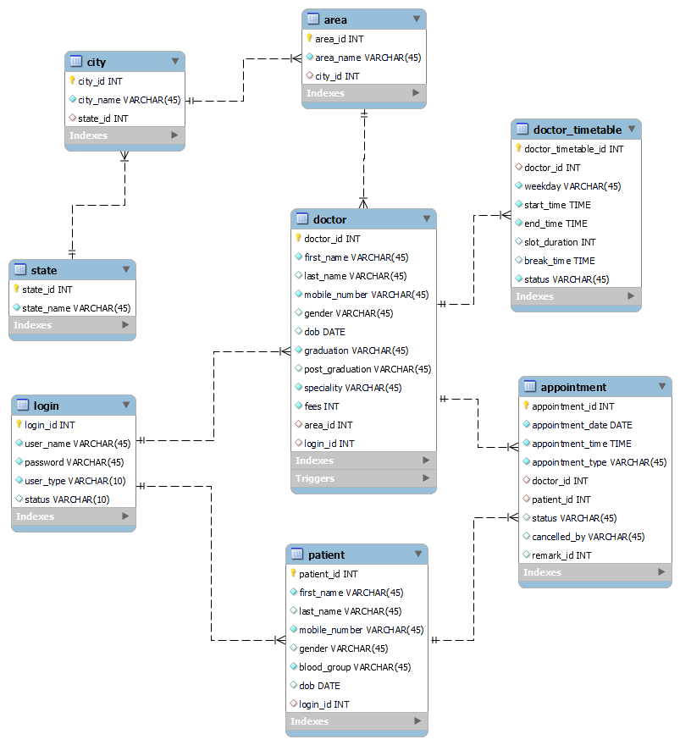

**E-R diagram shows database of Connecting To Doctor**

**8. Snapshots:**

**8.1 Home Page:**

Following snapshot shows the Home page for Connecting To Doctor.

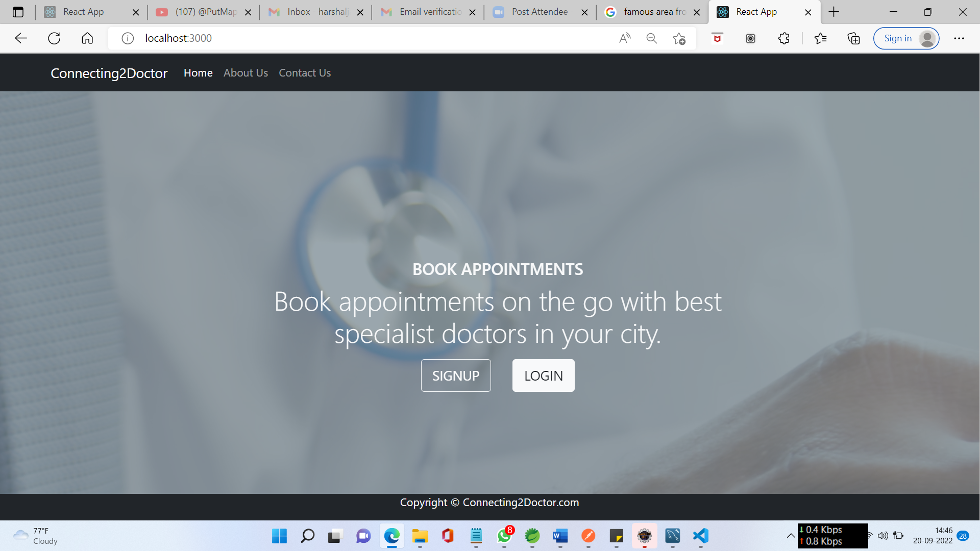

This page contains following controls

* Home
* About Us
* Contact Us
* Sign Up (Patient)
* Login (Admin, Doctor, Patient)

**8.2 About and Contact Page**

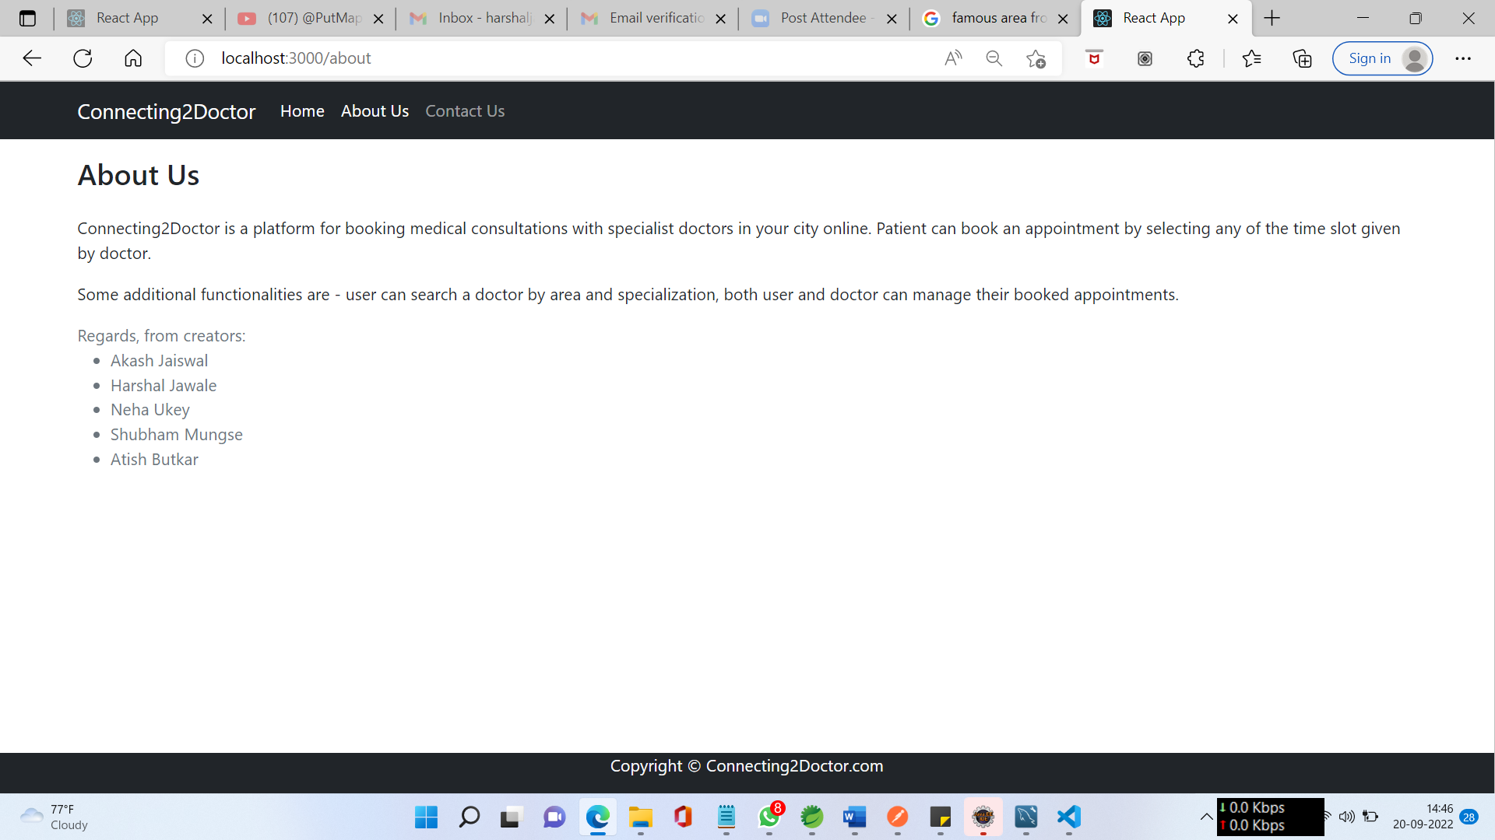

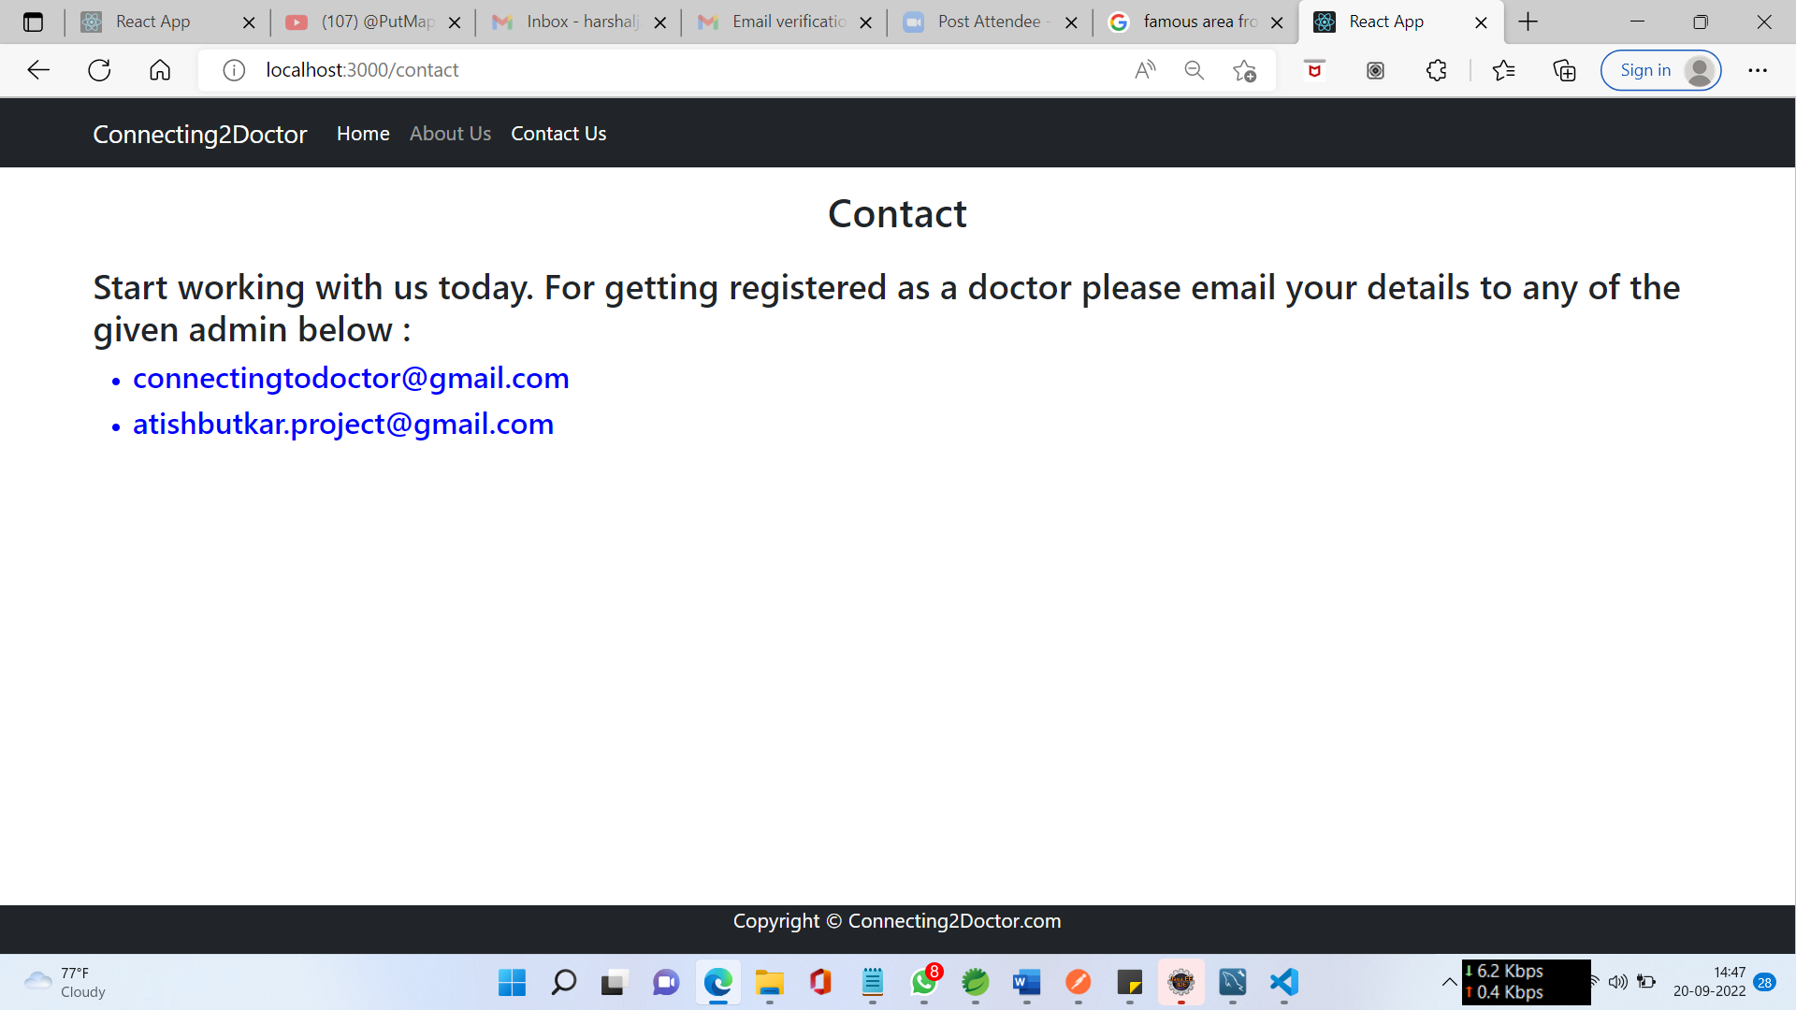

**8.3 Login Page**

Following snapshot shows the Login page for Connecting To Doctor.

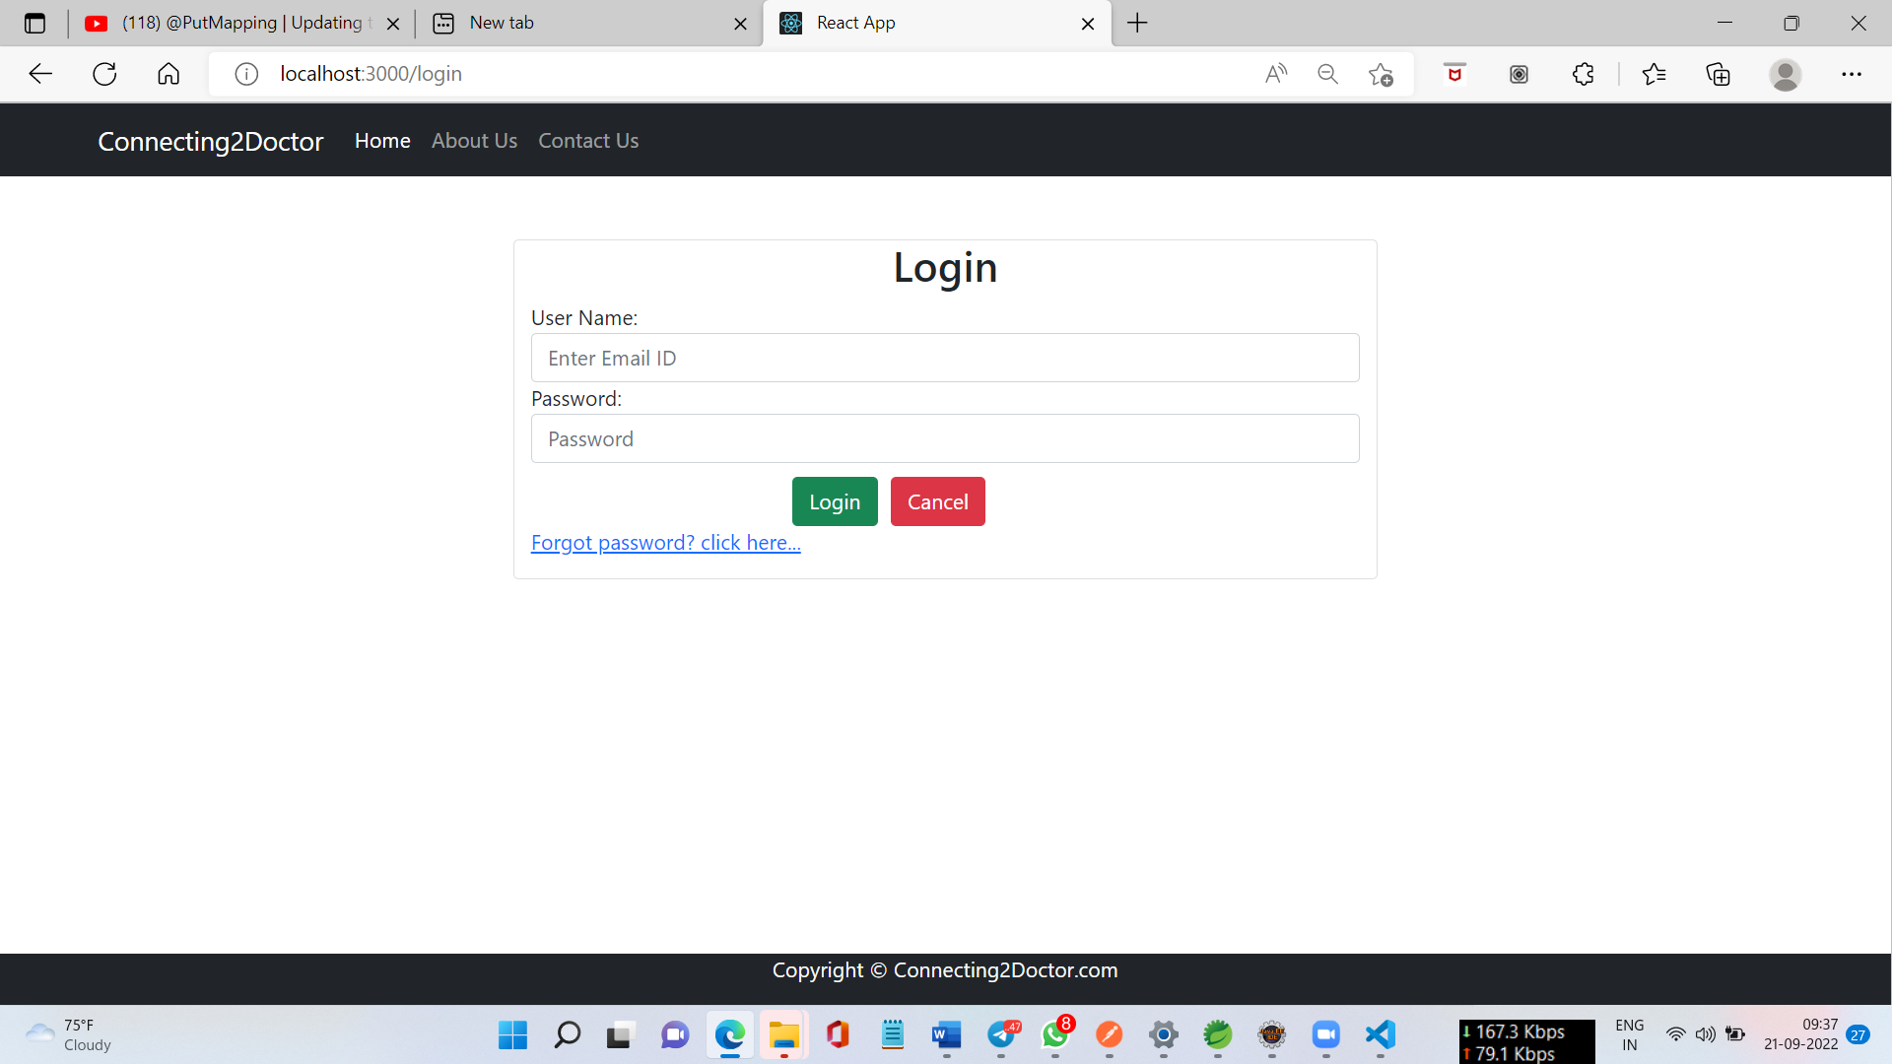

**8.4 Patient Registration Page**

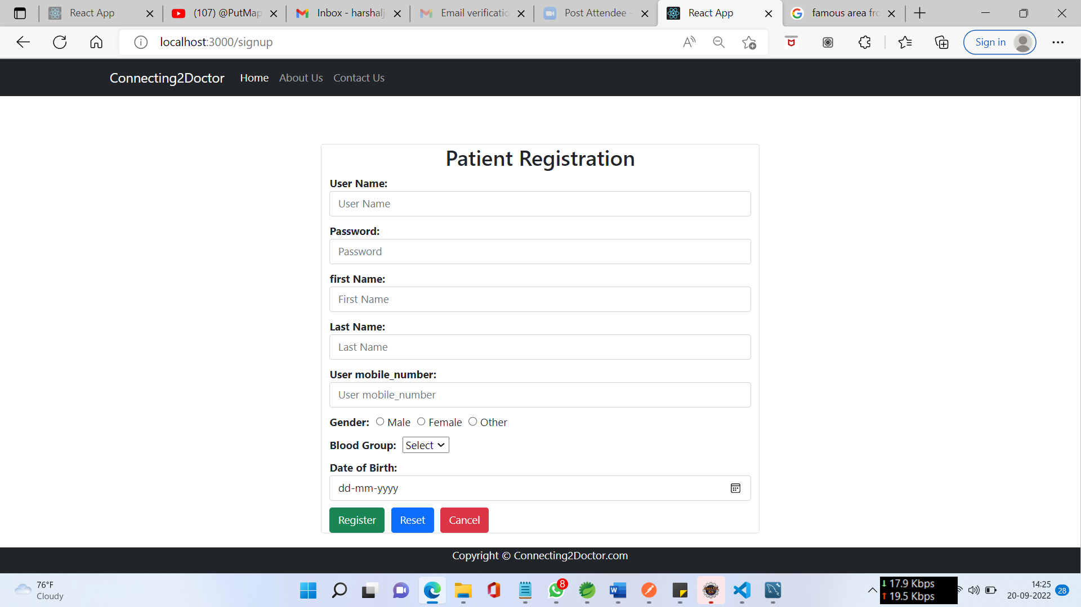

**8.5 Admin Dashboard**

**8.5.1 Admin Home Page**

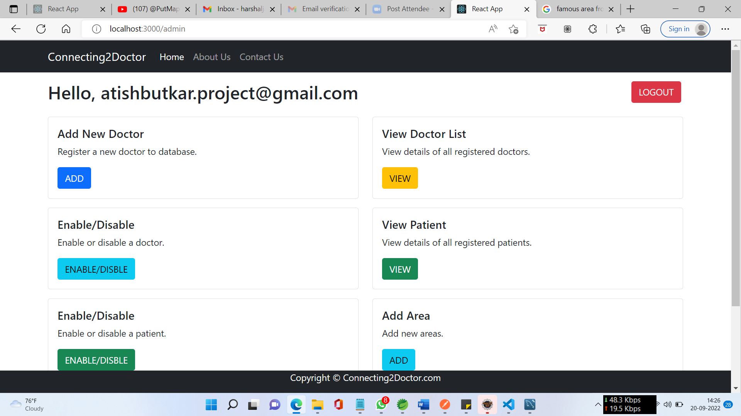

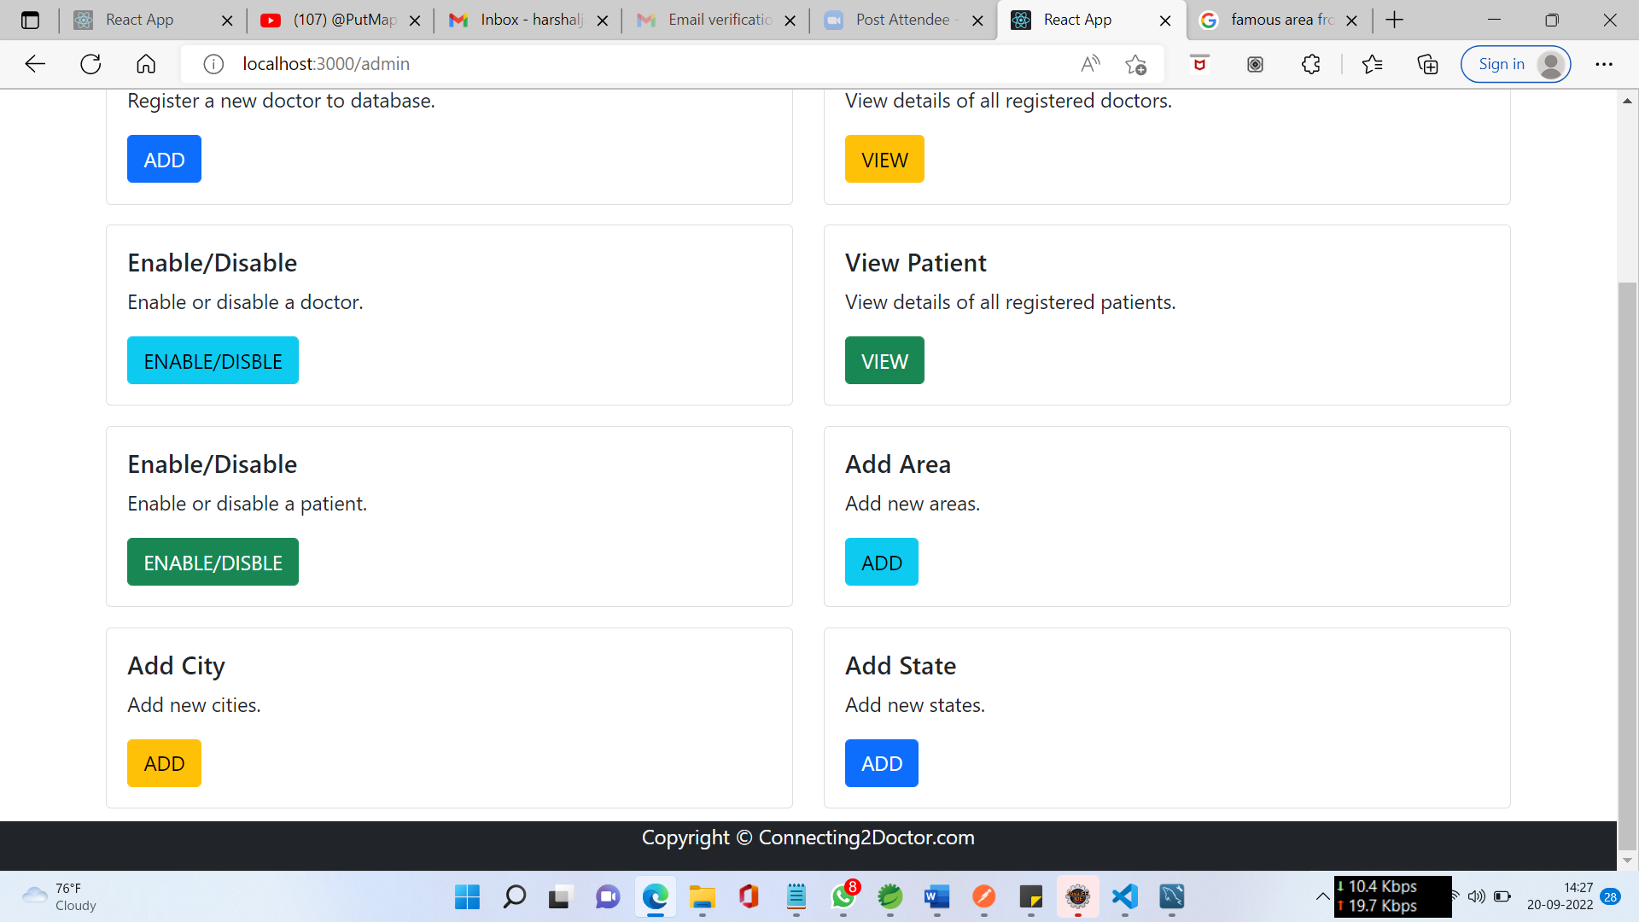

**8.5.2 Doctor Registration Page**

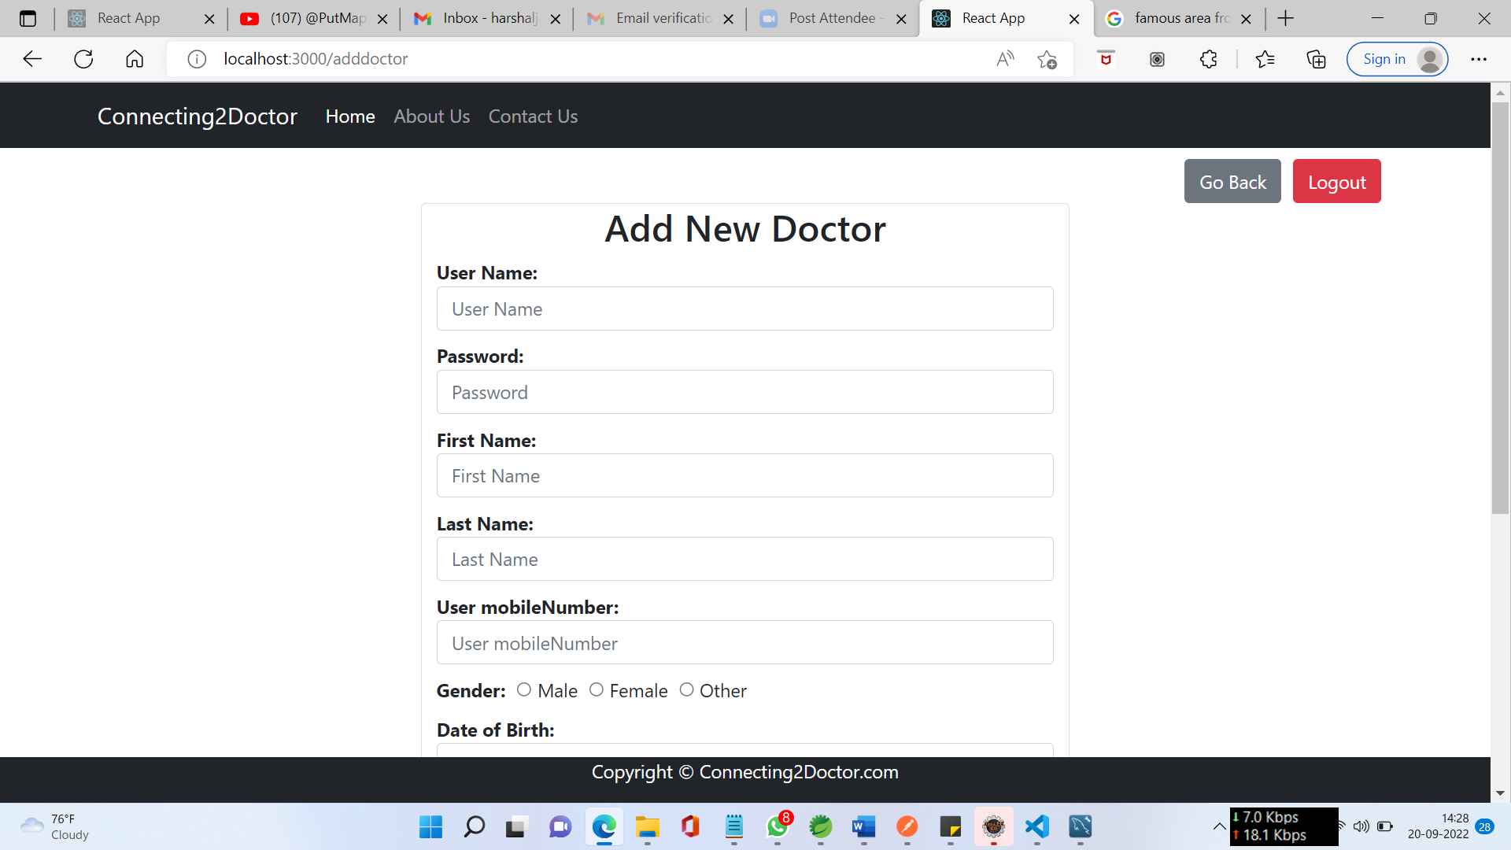

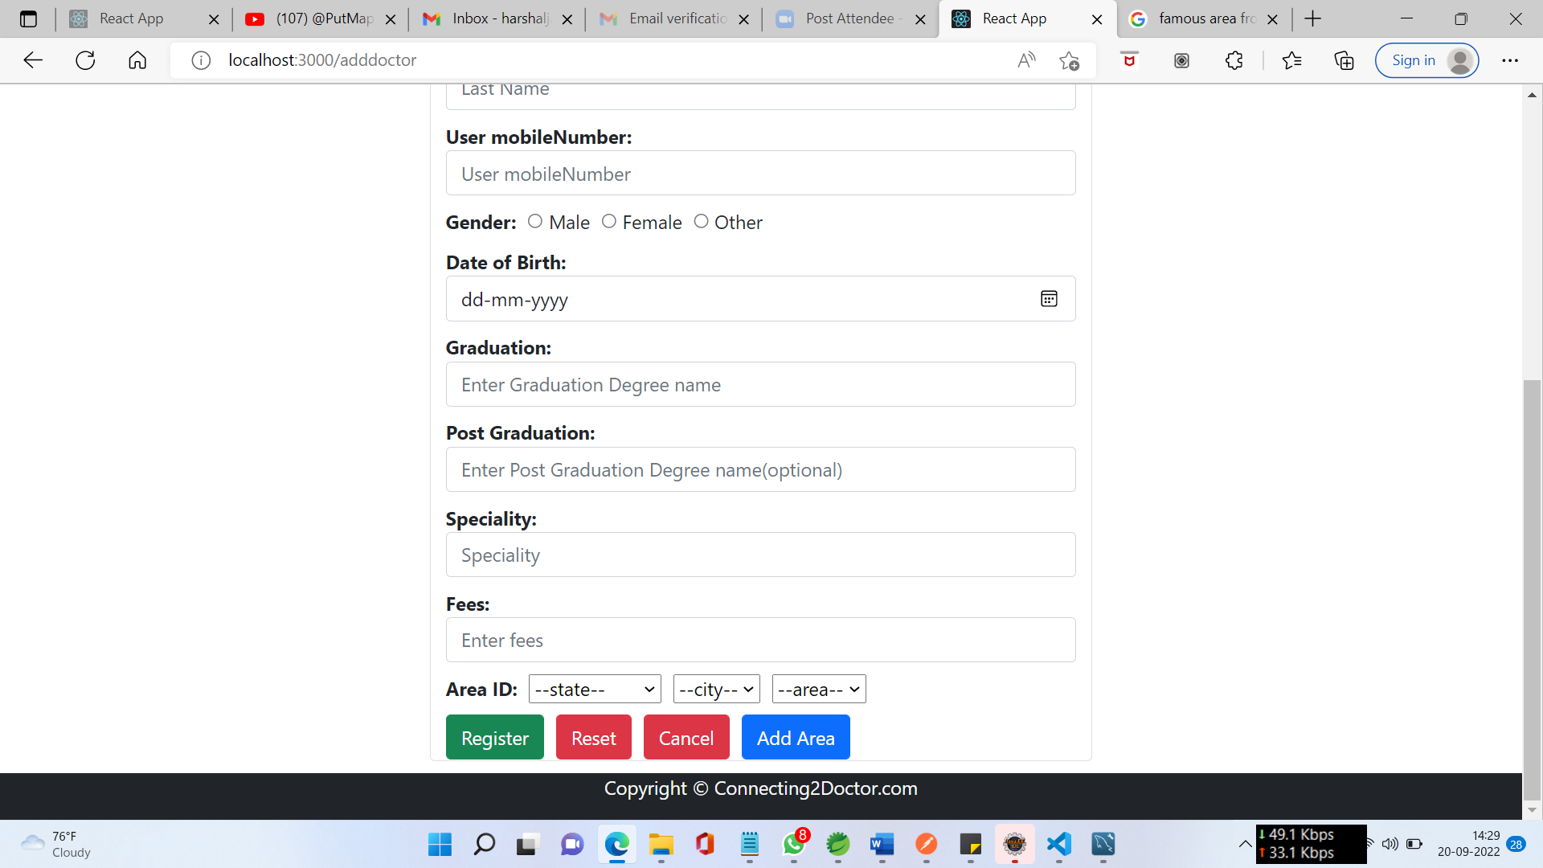

**8.5.3 View Doctor**

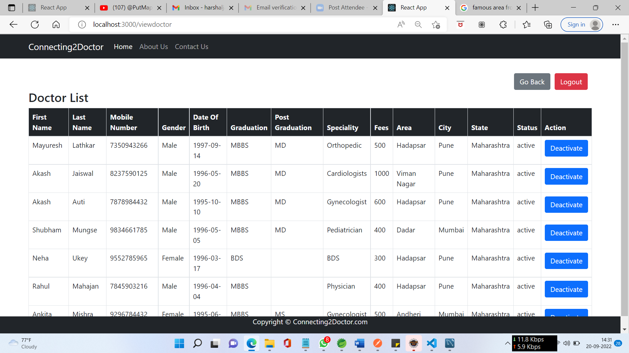

**8.5.4 View Patient**

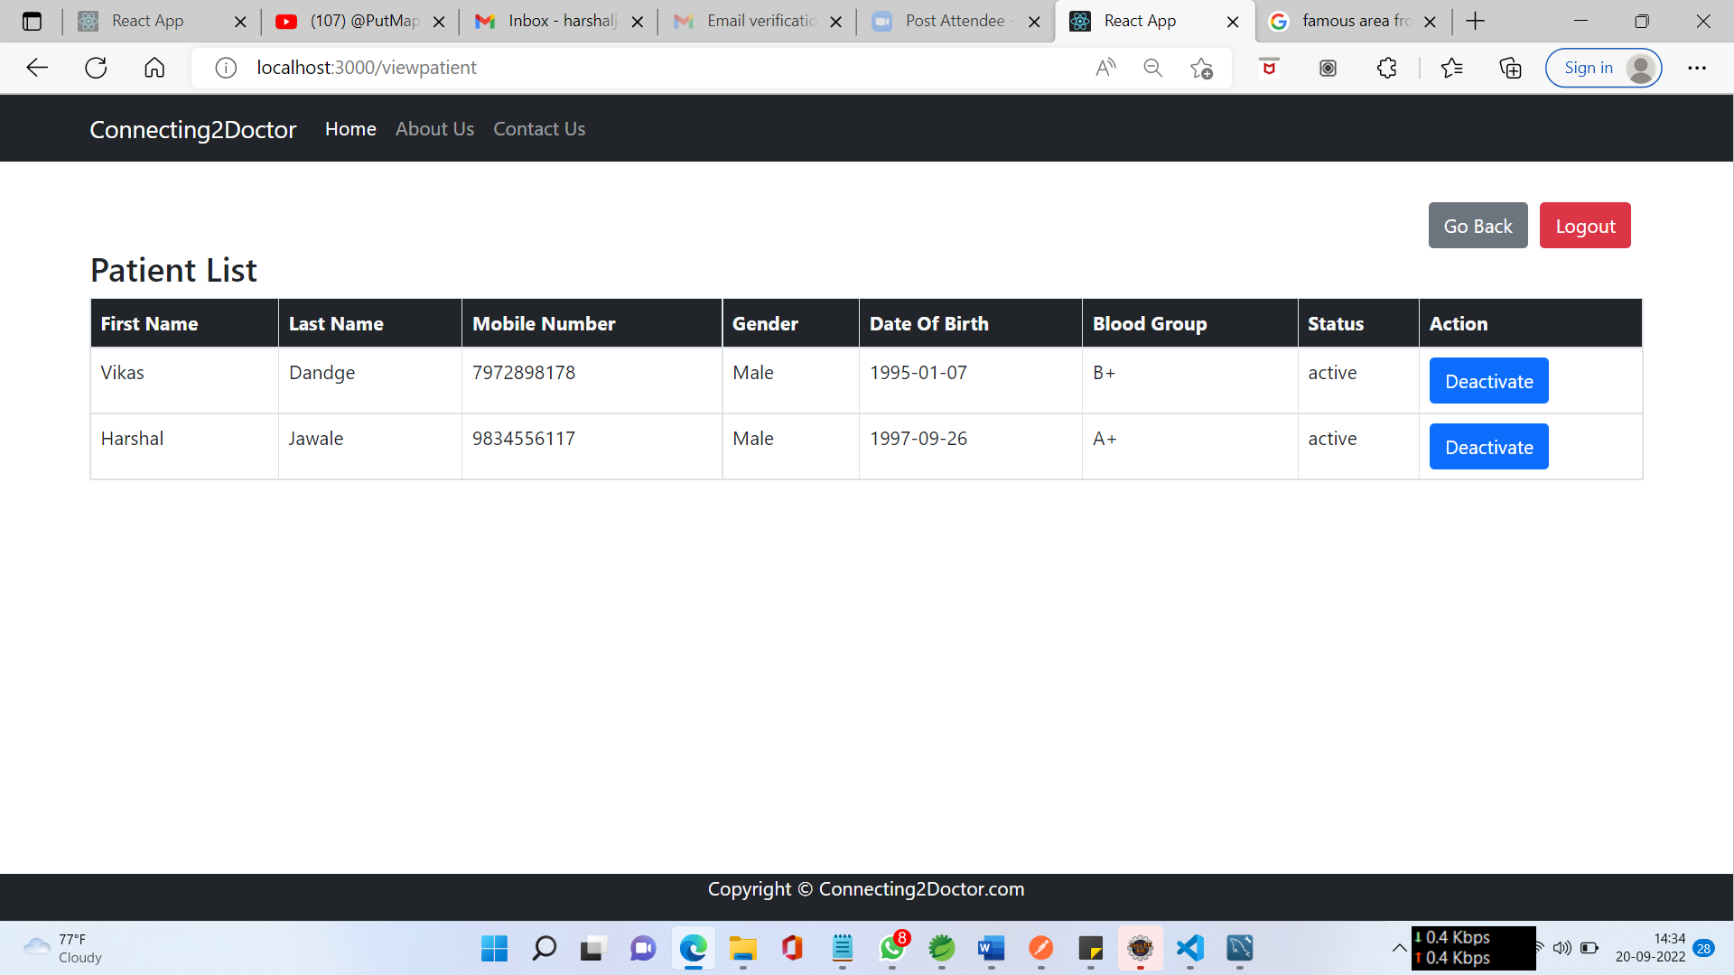

**8.5.5 Manage Account**





**8.5.6 Manage Location**

8.5.6.1 Add Area

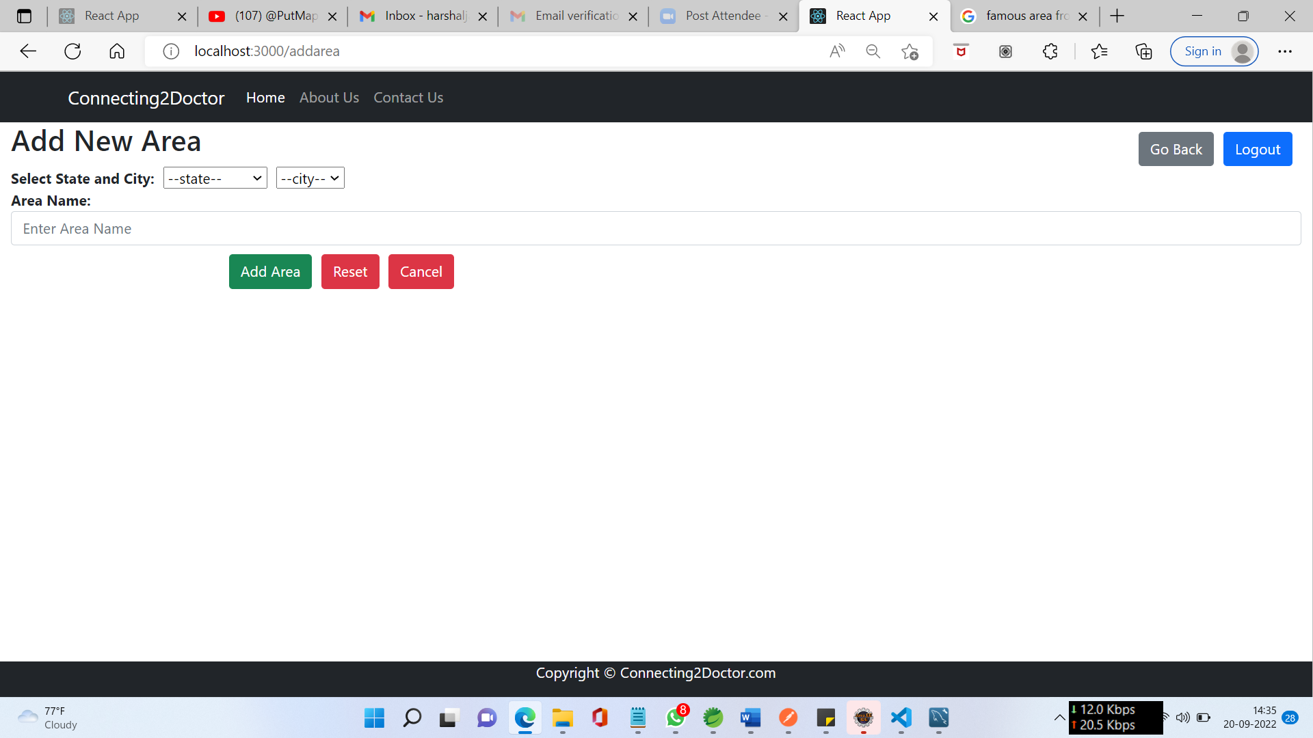

8.5.6.2 Add City

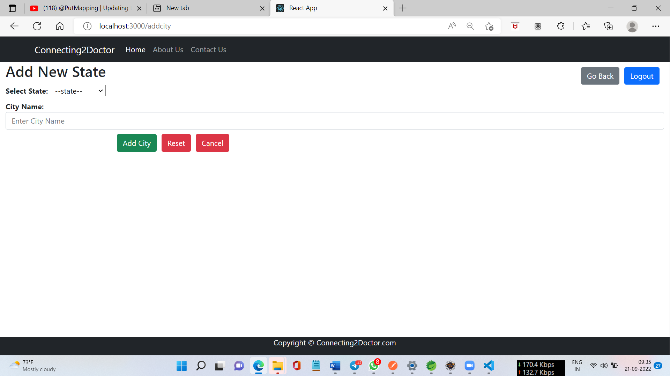

8.5.6.3 Add State

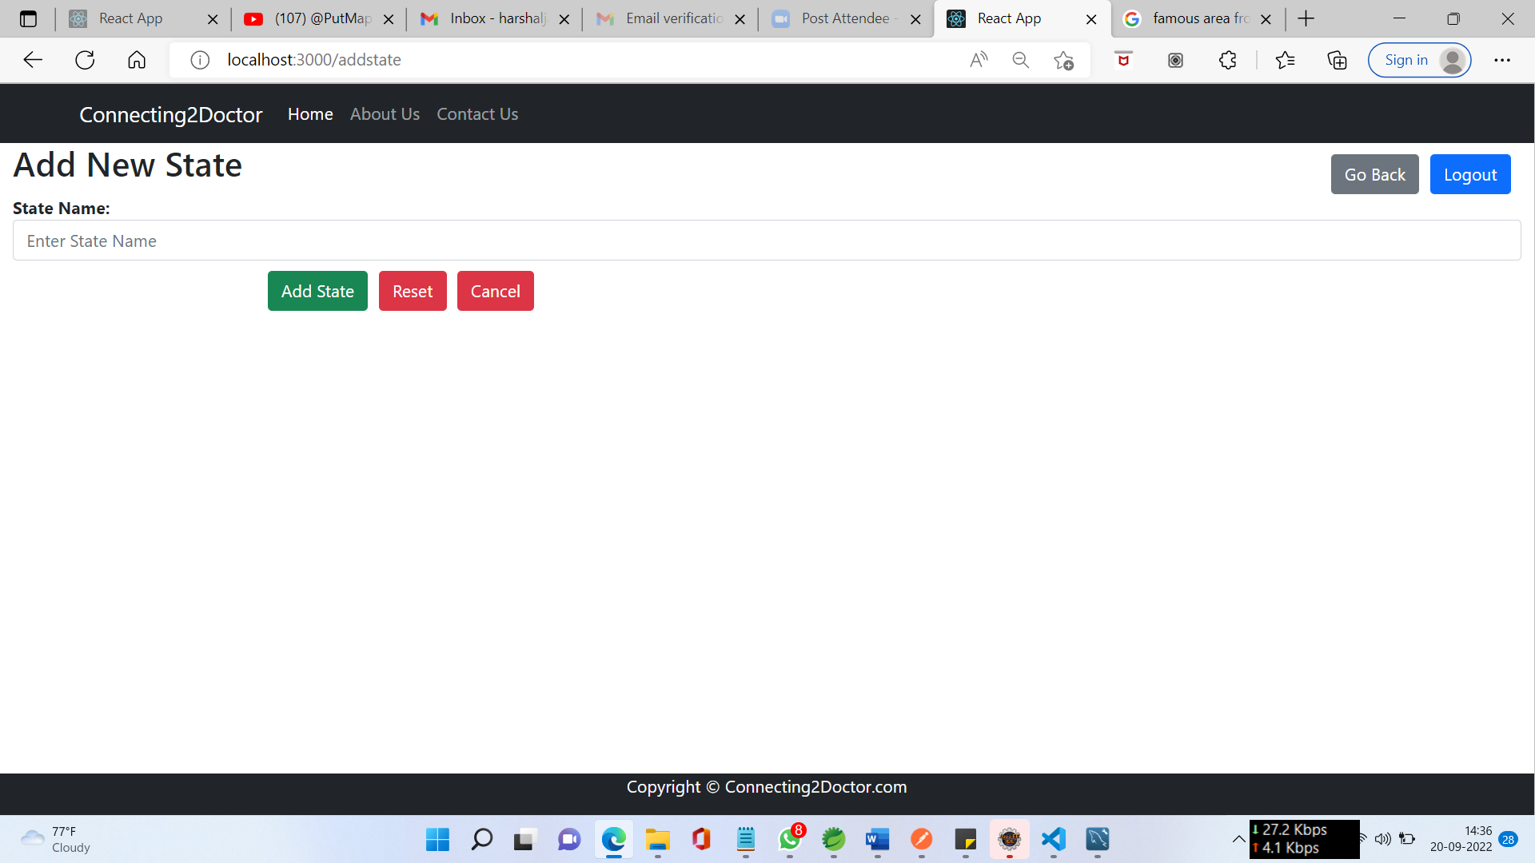

**8.6 Doctor Dashboard**

**8.6.1 Doctor Home Page**

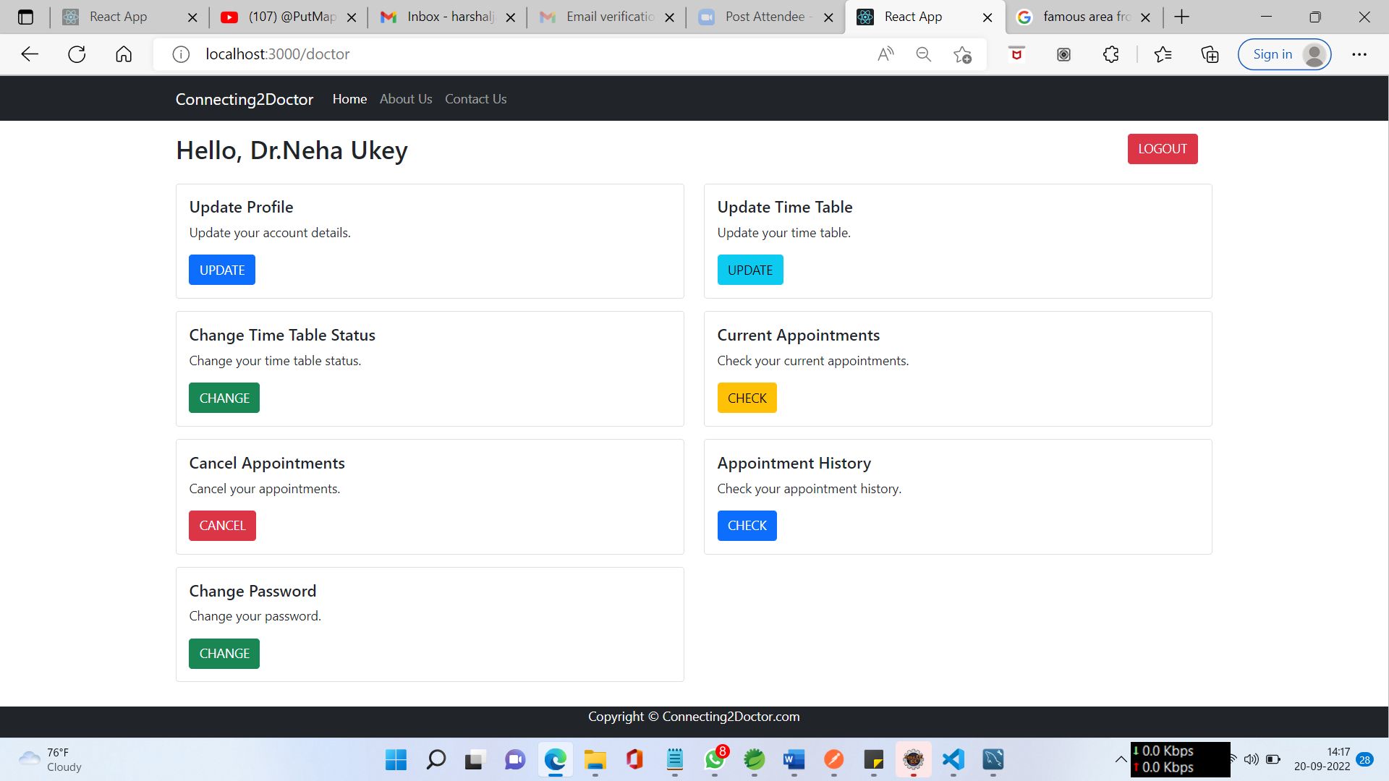

**8.6.2 Update Profile**

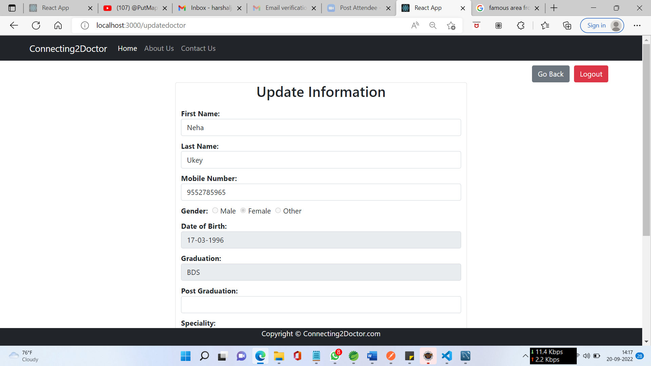

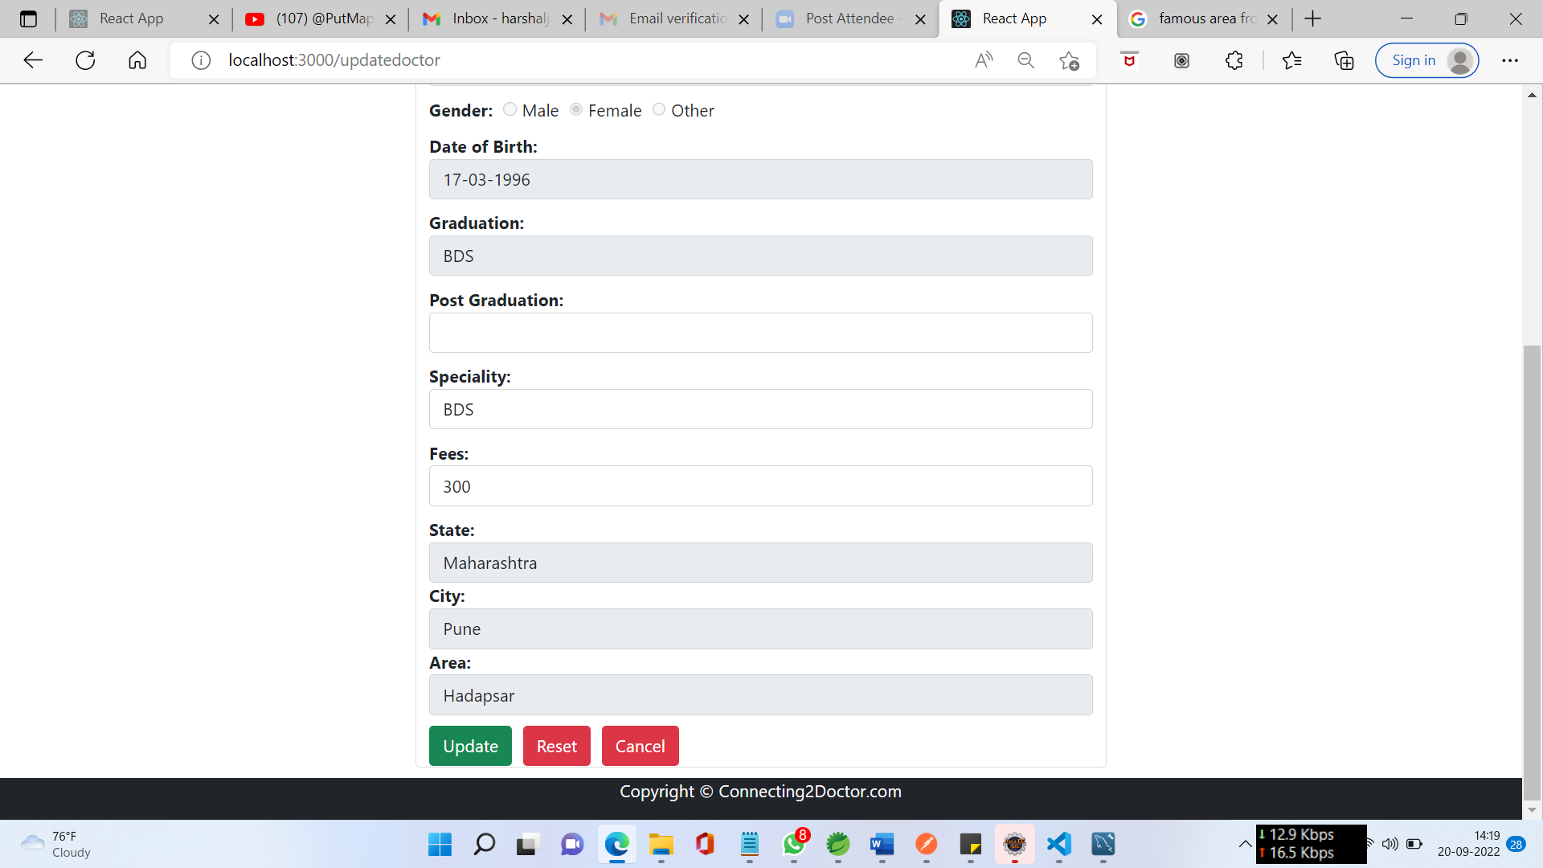

**8.6.3 Manage Time Table**

8.6.3.1 Update Status

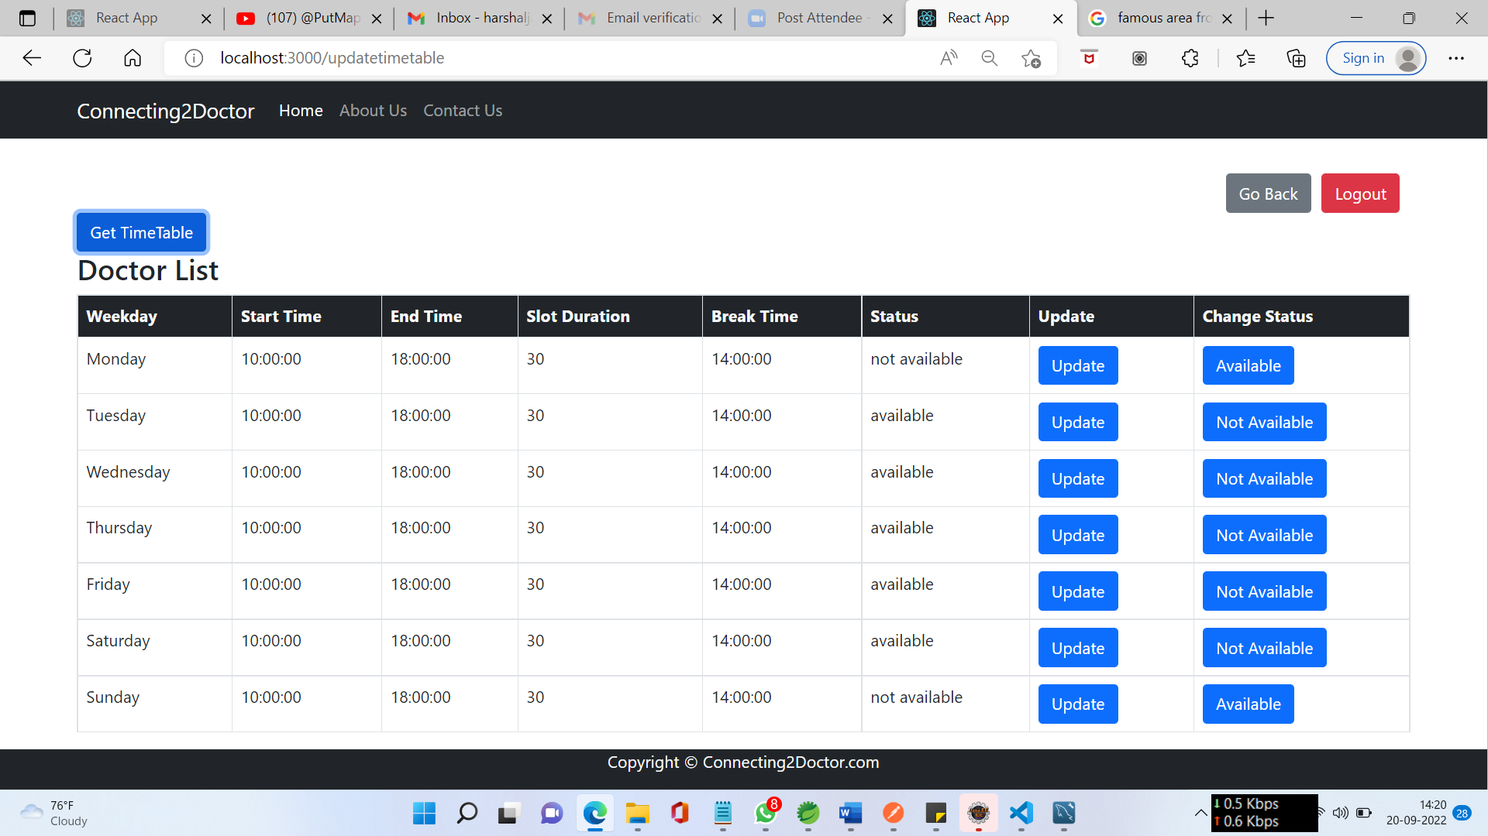

8.6.3.2 Change Time Table

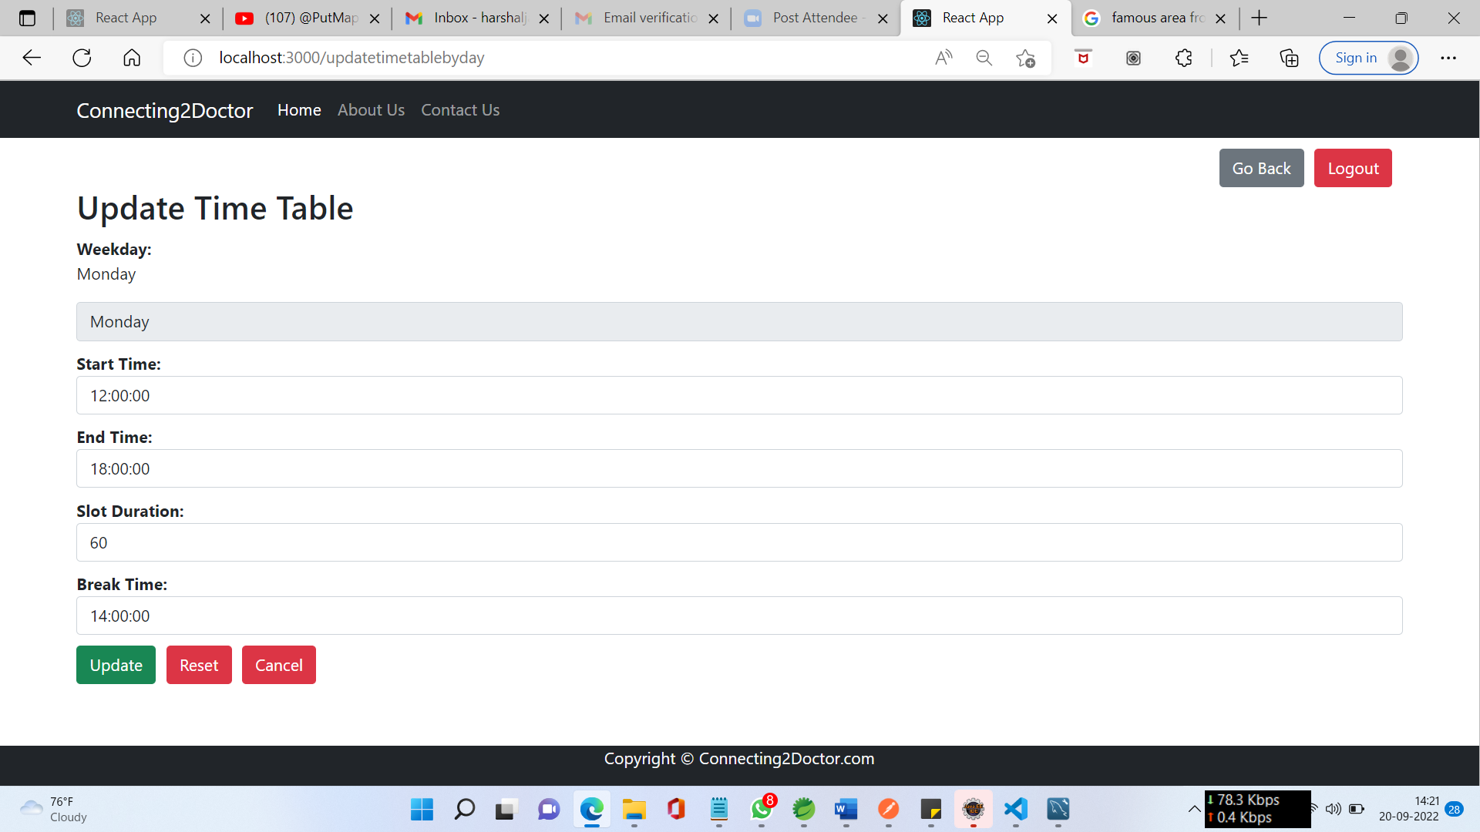

**8.6.4 View/Cancel Appointment**

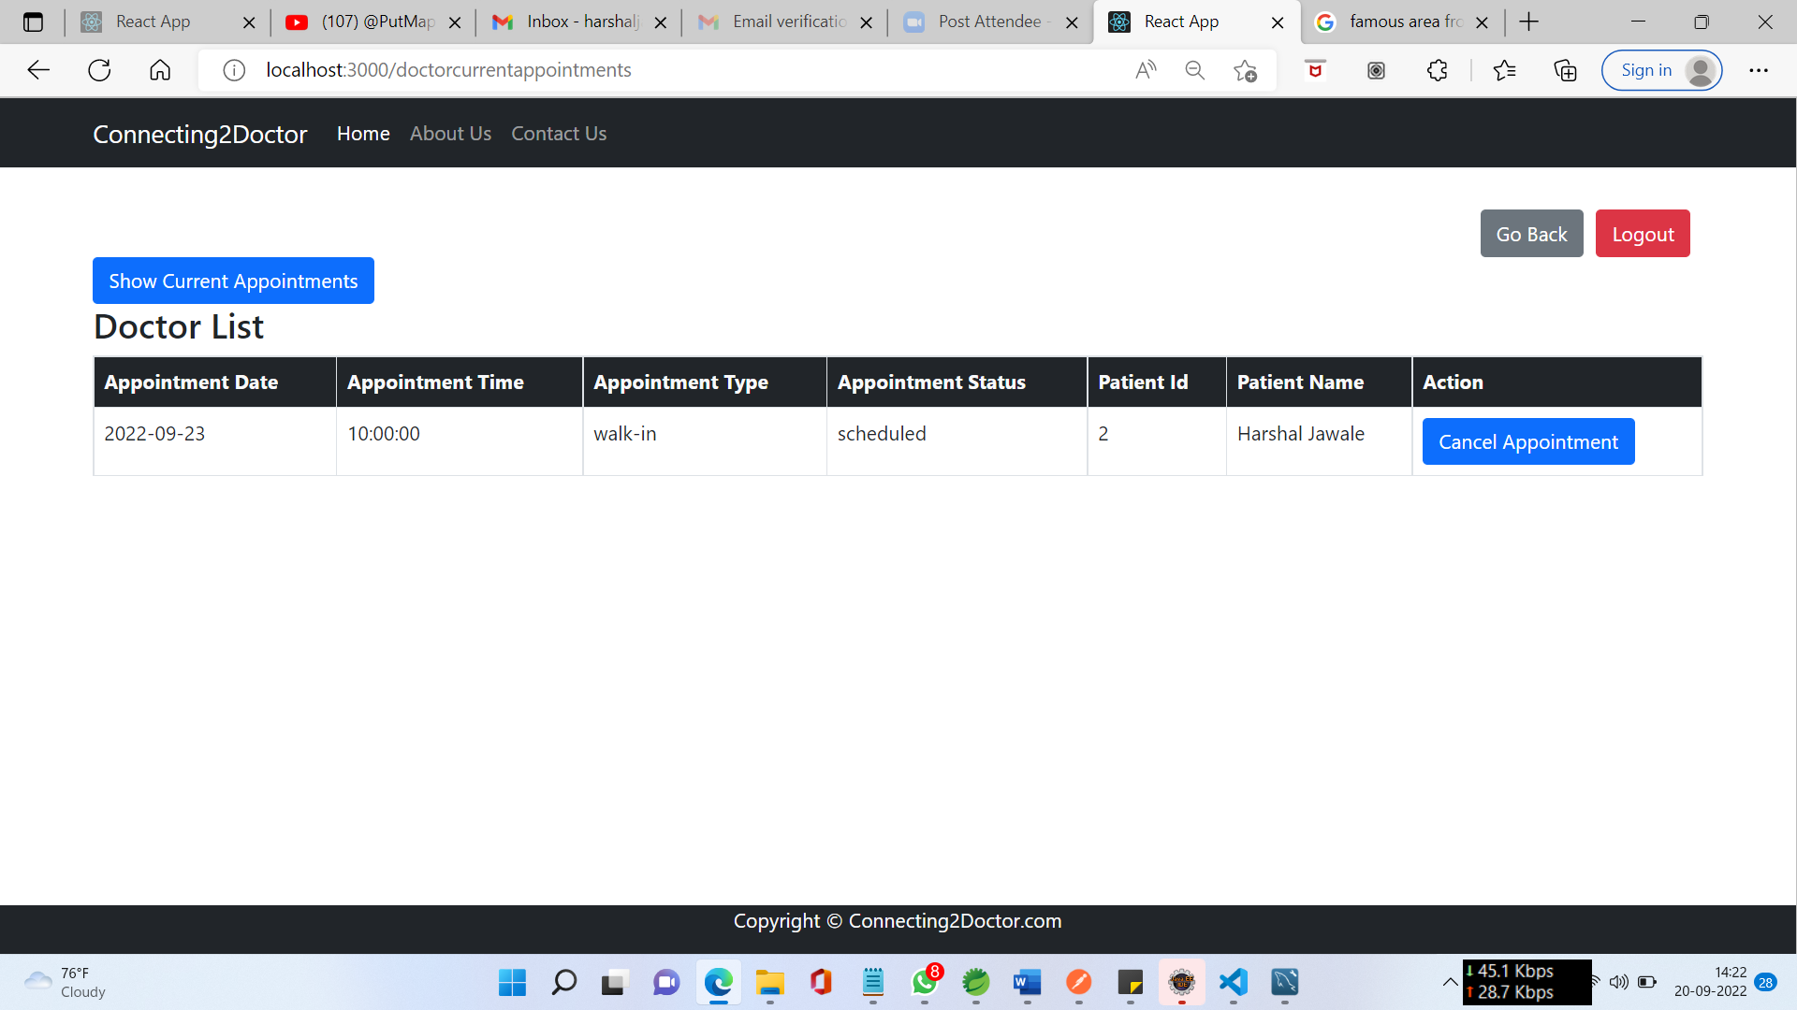

**8.6.5 Appointment History**

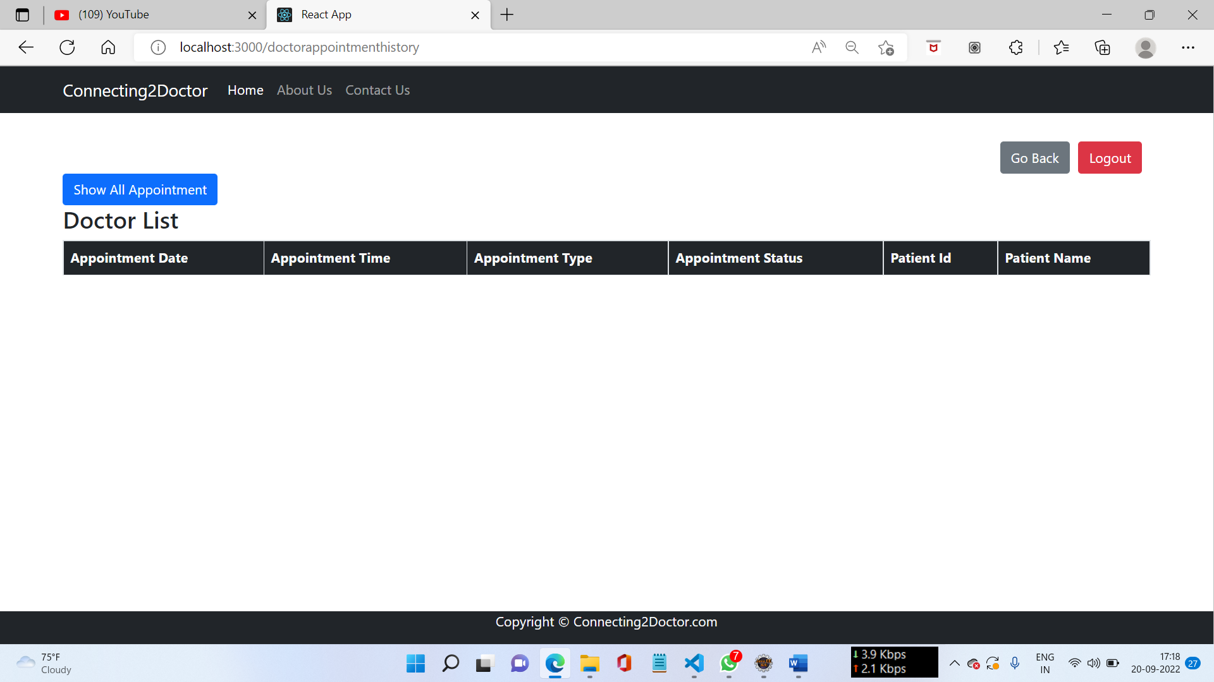

**8.6.6 Change Password**

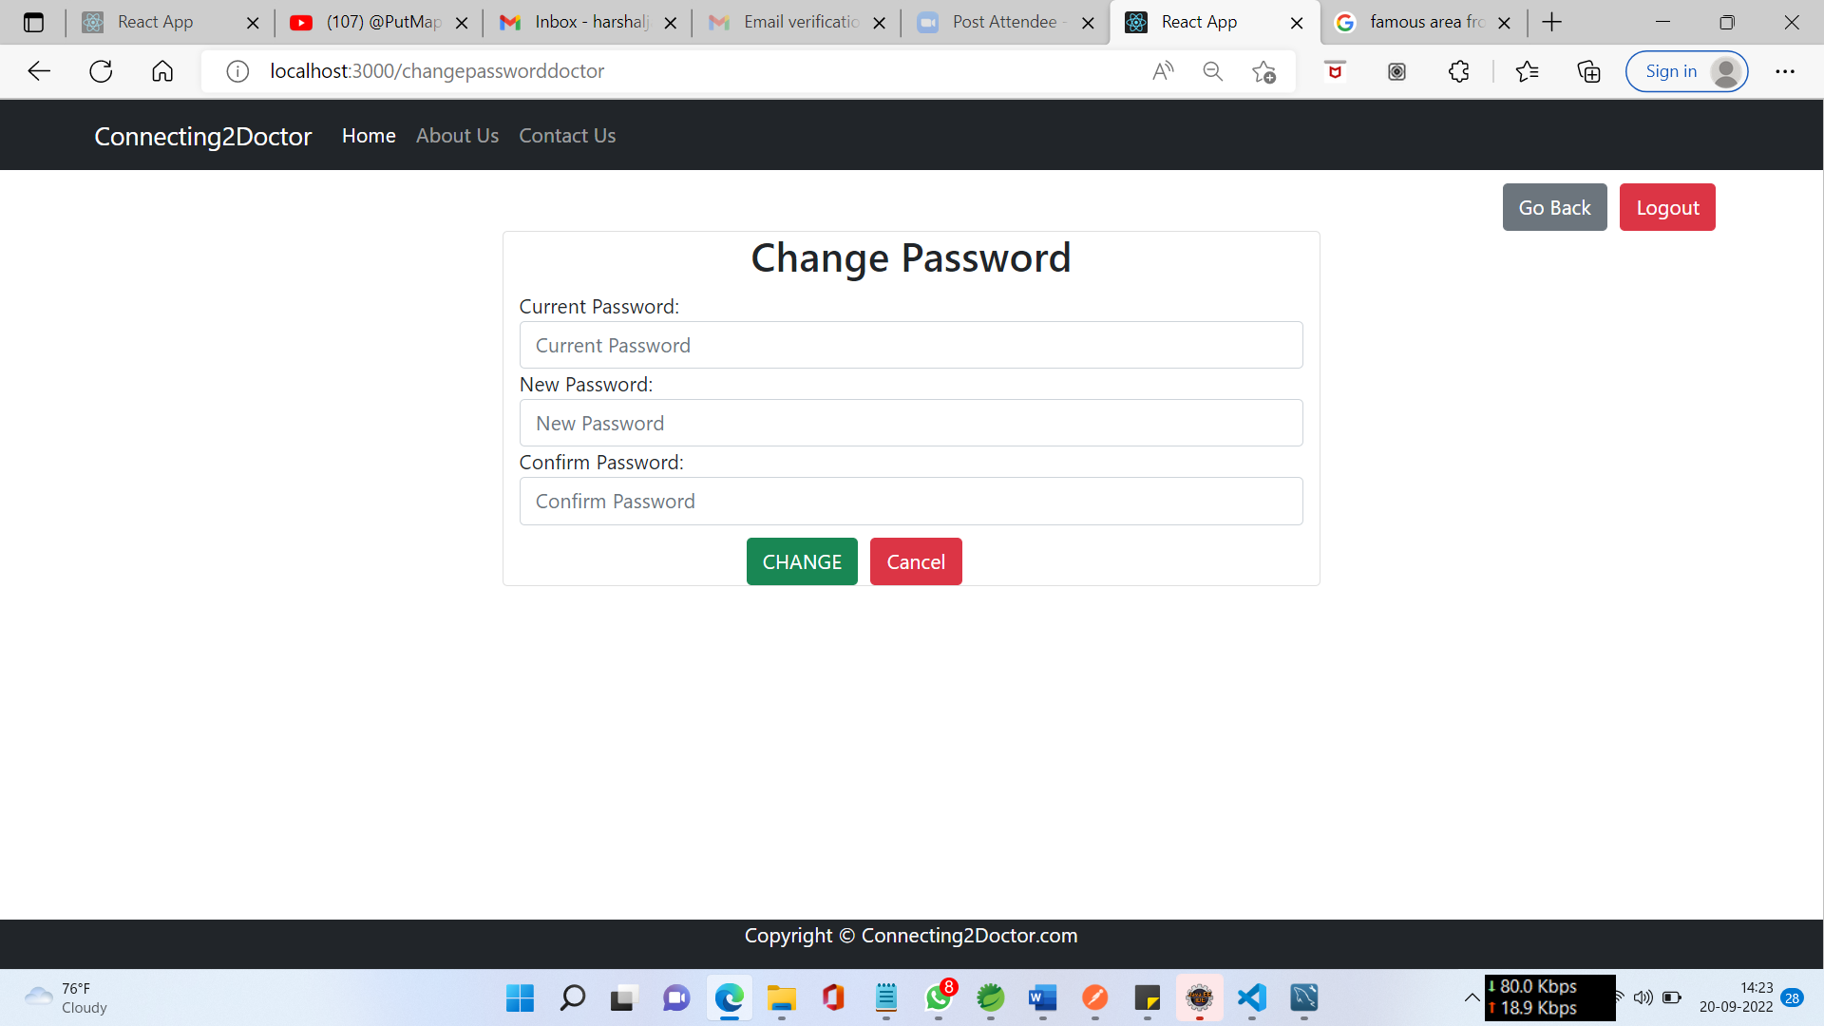

**8.7 Patient Dashboard**

**8.7.1 Home Page**

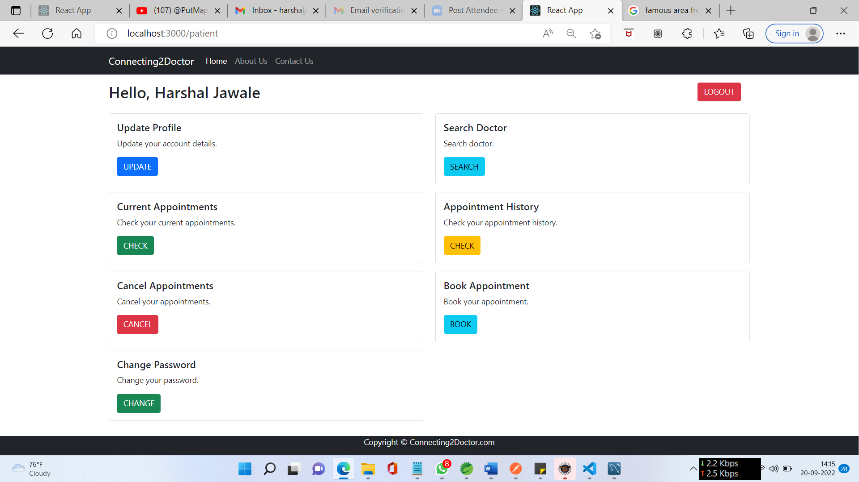

**8.7.2 Update Profile**

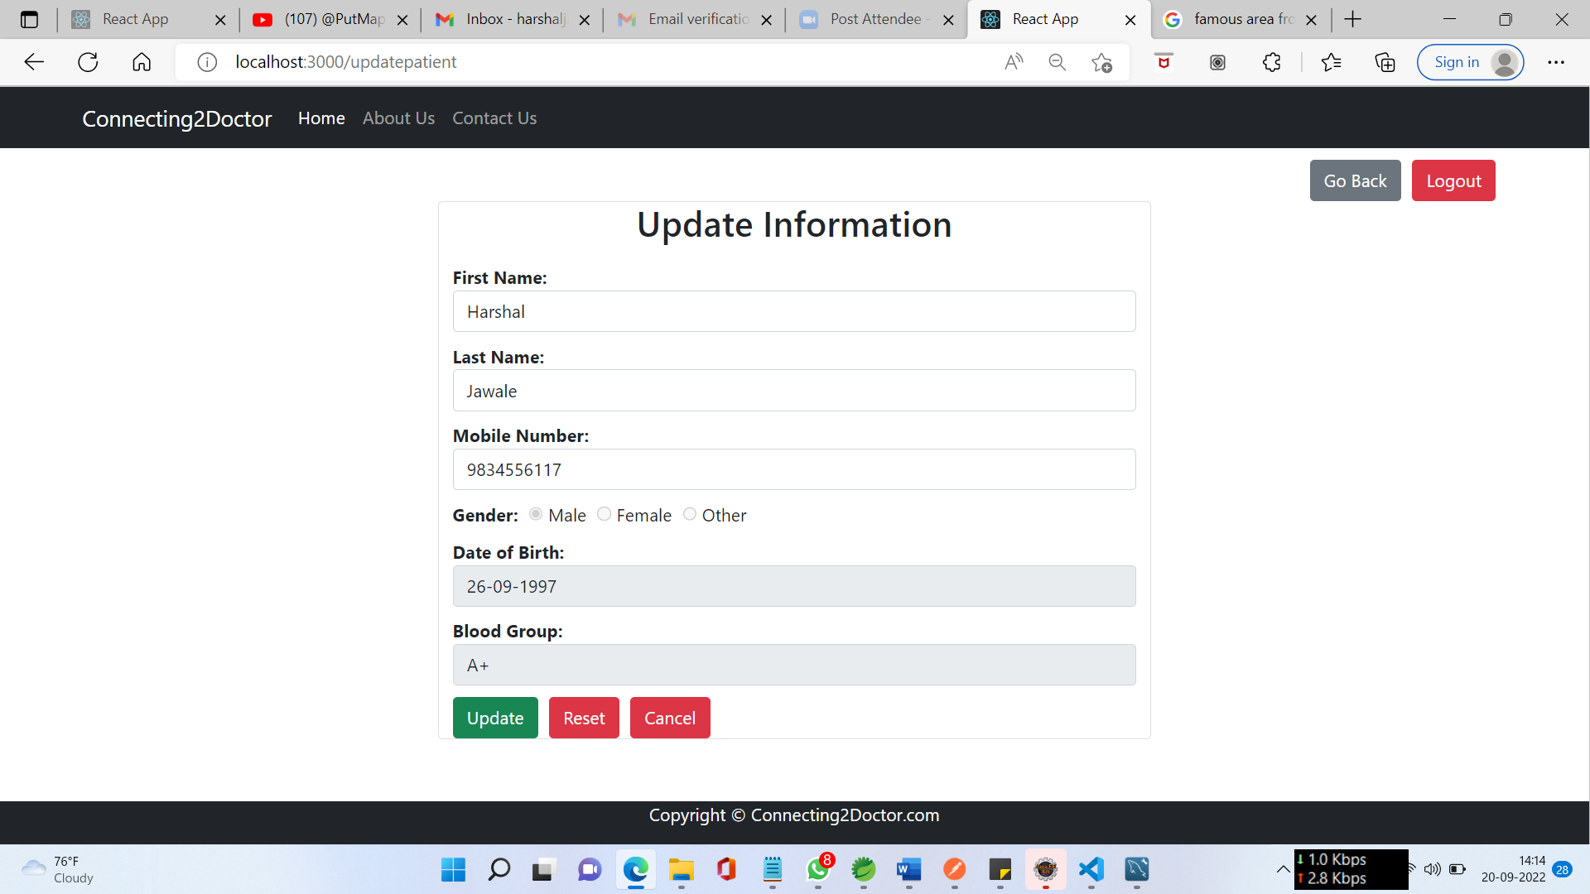

**8.7.3 Search Doctor**

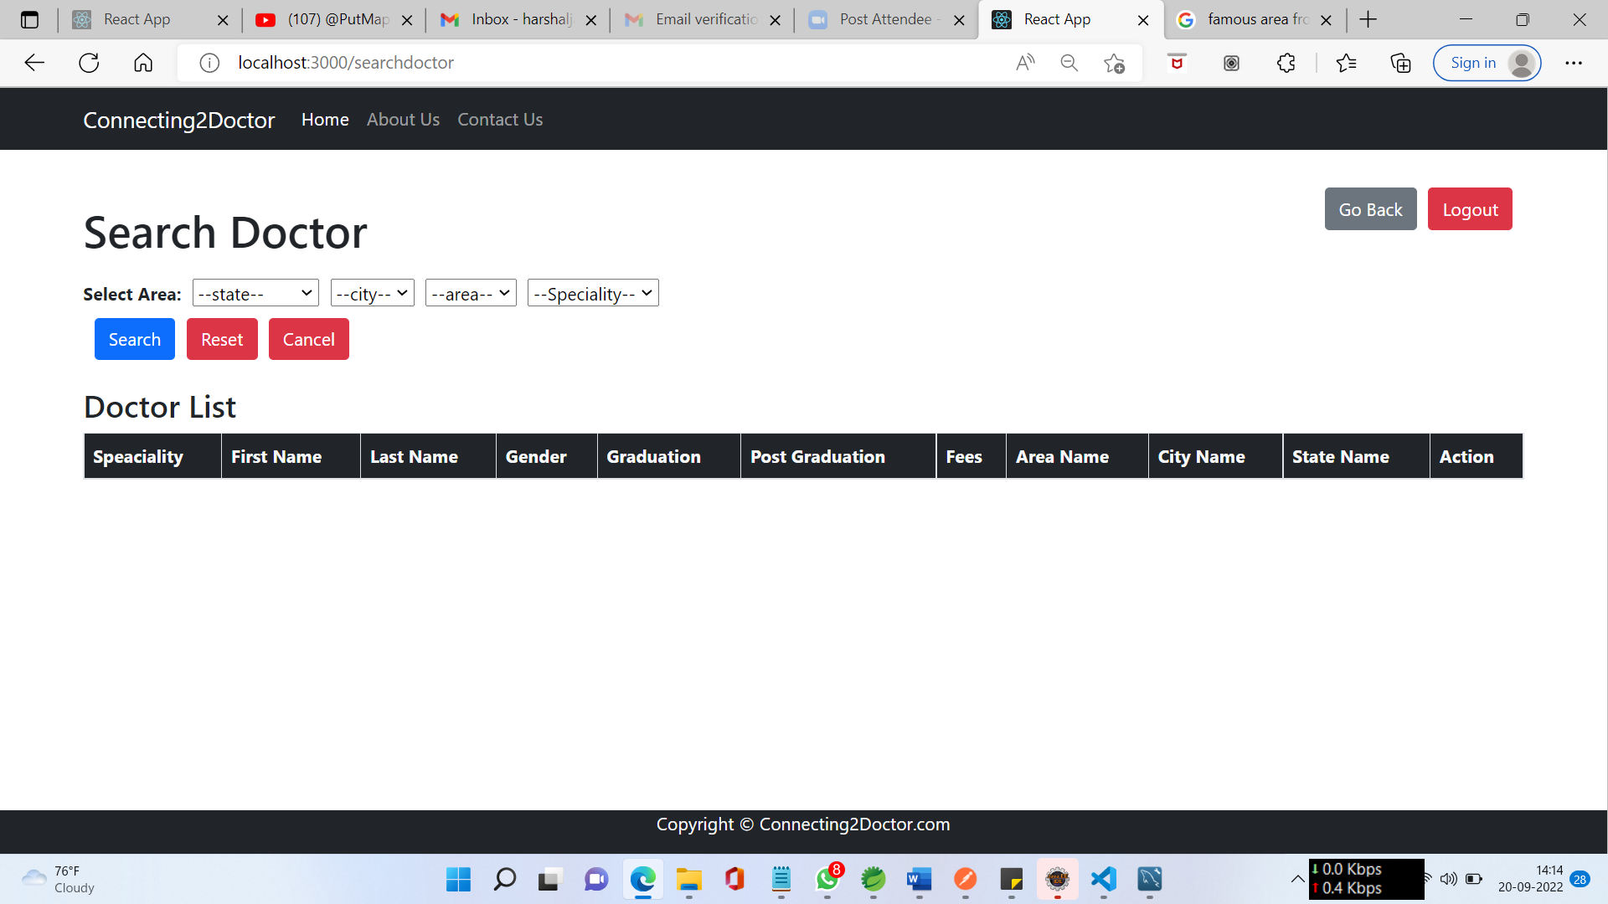

**8.7.4 Book Appointment**

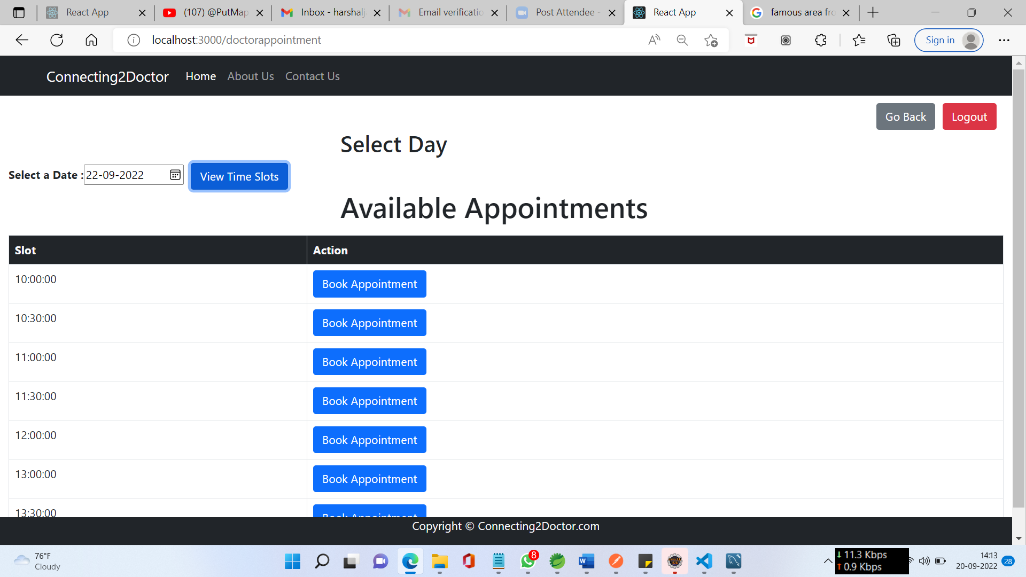

**8.7.5 View/Cancel Appointment**

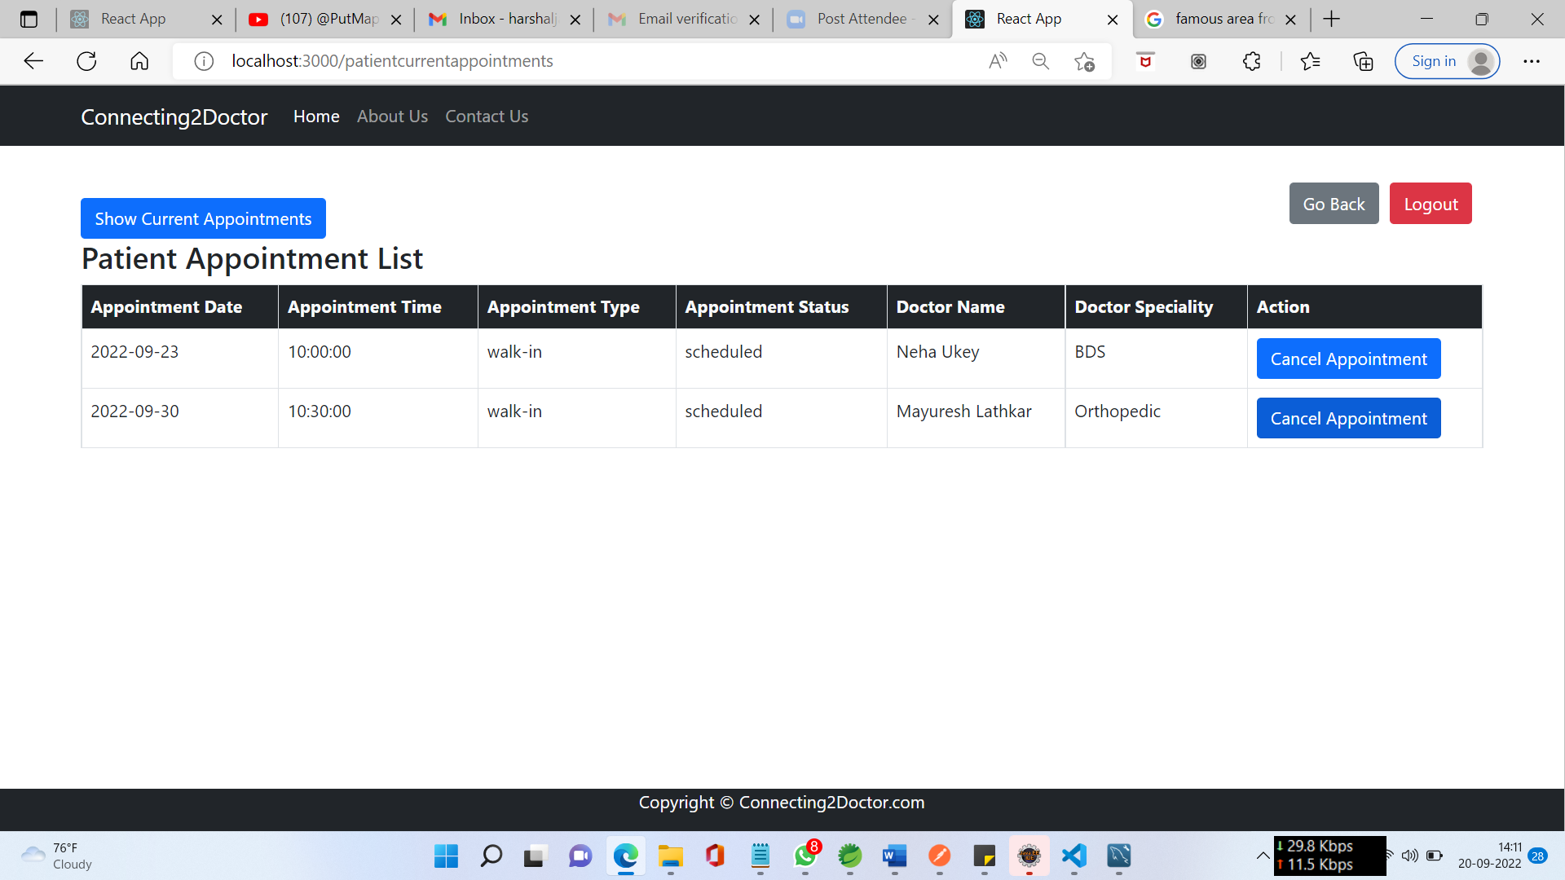

**8.7.6 Appointment History**

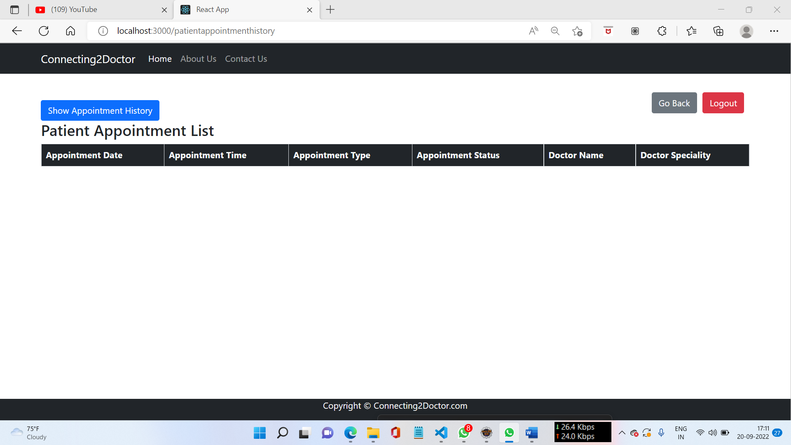

**8.7.7 Change Password**

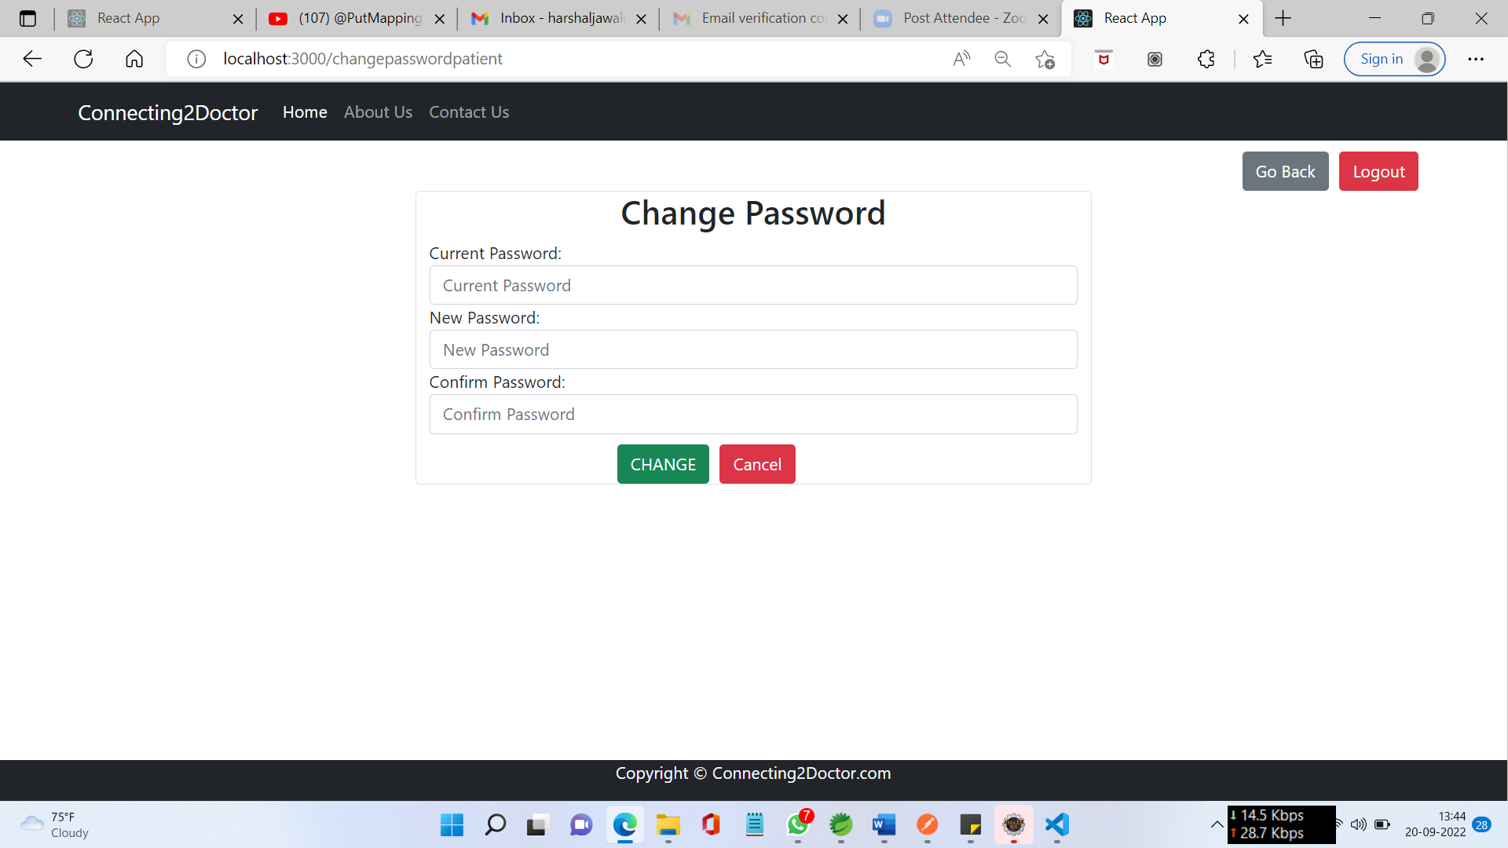

**9. CONCLUSION AND FUTURE SCOPE**

**9.1 Future Scope**

• We can add Online Consultation and online fee payment

• Home visit of doctor

• Blood Bank

• Pathology (Home Service)

**9.1 Conclusion**

Internet is changing the world. Though it is not possible to entirely switch the healthcare sector to online mode. But definitely it can help in bridging the gap between Patient and Doctor. Our project Connecting To Doctor serves the purpose of bridging the gap. It makes easy for the patient to search for the doctor in his/her locality or in any other locality. Addition to this patient can also search for the doctor based on the doctor’s specialty.

**9.3 References**

* Reactjs.org
* Greekforgreek.org
* Springboot.io